|  |
| --- |
|  |
| Construction of a dehydrated and rectified  alcohol manufacturing plant |
|  |
| **Investment Project** |

**July 2013**

TABLE OF CONTENTS

PROJECT SUMMARY 3

1. Introduction: justification of the investment 4

I. RATIONALE FOR INVESTMENT IN BIOFUEL - bioethanol 4

II. Bioethanol – fuel WITH PROSPECTS 10

III. Statistics and EU documents on the liquid biofuels – development 12

2. Investment: production of dehydrated and rectified spirit 16

I. Assumptions. 16

II. Raw materials for production of spirit. 17

III. Analysis of raw material prices. 19

A. Rye and maize prices in Poland to 2015. 20

B. Situation in the global cereal market to 2015. 21

1.1. Production of cereals in the world and its changes 21

1.2. Cereal prices on the world markets 22

1.3. Forecasted cereal prices on world markets in the next years 24

1.4. Prospects of cereal prices in the EU and OECD. 26

IV. Analysis of production costs. 34

V. Analysis of legal and fiscal regulations regardIng bioethanol. 36

3. Assumptions of the investment 38

I. Location of the investmEnt – justification. 38

II. Technical description of the investmenT. 38

A. Production plant infrastructure. 38

B. Production plant project assumptions. 39

1.1. Production capacity 39

1.2. Raw material 40

1.3. Technical data. 41

1.4. Technical factors and characteristics of the products. 42

1.5. Infrastructure 43

1.6. Storage and distribution of the alcohol. 46

III. Organization of the investment process. 47

A. Execution………………………………………………………………………………………………….47

B. Bank Supervision Officer……..…………………………………………………………………..…47

IV. Investment budget. 48

V. Investment schedule. 48

VI. Funding. 48

A. Assumptions 48

B. Equity 49

C. Long-term credit 49

D. VAT credit 49

E. Credit for the purchase of raw materials needed for production 50

F. Expected conditions of the credit 50

G. Collateral 50

4. Financial projections of the investment 50

I. Assumptions 50

II. Analysis of profitability of the investment project 54

5. Management and structure of employment 54

6. Marketing analysis and plan of the ASPEN company 63

I. Characteristics of the industry in the eu 63

II. AllowanceS and incentiveS policy 64

III. Analysis of prices and profits from the sale of biofuels. 65

IV. ANALYSIS OF Competition 66

7. SWOT analysis 68

Appendices

Aspen financial model - design, construction and start-up of the project

# PROJECT SUMMARY

|  |  |
| --- | --- |
| **Investor:** | “Aspen” Sp. z o.o. |
|  | 63-100 Jarocin, Batorego 2 |
|  |  |
| **Investment:** | Construction of a dehydrated and rectified alcohol manufacturing plant |
|  |  |
| **Production capacity:** | 125 million litres of 100% alcohol  including:  105 million litres of dehydrated alcohol  20 million litres of rectified alcohol  115,5 thousand tonnes of substantial fodder |
|  |  |
| **Total investment budget:** | 338 million PLN |
|  |  |
|  |  |
| **Period of investment:** | September 2013 – December 2015 |
|  |  |
| **Production start-up:** | December 2015 |
|  |  |
| **Source of loan repayment:** | Sales of:   * bioethanol * rectified spirit (food, cosmetic and pharmaceutical products) * substantial fodder (DGGS). |
|  |  |
|  |  |

# Introduction: substantiation of the investment

## I. RATIONALE FOR INVESTMENT IN BIOFUELS - bioethanol

1. **Due to fluctuations of oil prices:**

- non-renewability of oil deposits,

- price increases,

- political uncertainty of oil deposits, e.g. Persian Gulf, Iran, Venezuela,

- limited global resources.

***Zachwianie dostaw ropy w latach 70-tych i w czasie wojny w Zatoce Perskiej zbiegło się z nadprodukcją rolniczą w Europie. Te dwa elementy stały się siłą napędową rozwoju wykorzystania surowców roślinnych na cele przemysłowe, w szczególności przetwarzania na paliwa płynne. Przemysłowa produkcja biopaliw rozwinęła się w krajach UE mających z jednej strony nadprodukcję rolniczą, z drugiej strony wysokie opodatkowanie paliw kopalnych. Taka sytuacja wpłynęła na świadome ograniczanie produkcji surowców żywnościowych na rzecz surowców przemysłowych, w tym energetycznych. Obecnie głównym argumentem motywującym działania w tym zakresie jest zaniepokojenie globalnym i lokalnym zanieczyszczeniem środowiska. Transport jest dynamicznie rozwijającym się sektorem, praktycznie w 100% zależnym od ropy naftowej. Równocześnie sektor ten ma coraz większy udział w zanieczyszczaniu atmosfery - emisje CO2 z transportu rosną systematycznie. Świadomość tych faktów znalazła odbicie w przyjętej we wrześniu 2001 r. przez Komisję Europejską Białej Księdze dotyczącej transportowej polityki UE do 2010 r. oraz wpłynęła na przyjęcie w listopadzie 2000 r. tzw. Zielonej Księgi UE dotyczącej strategii europejskiej w zakresie bezpieczeństwa energetycznego COM(2000)769. Zachwianie dostaw ropy w latach 70-tych i w czasie wojny w Zatoce Perskiej zbiegło się z nadprodukcją rolniczą w Europie. Te dwa elementy stały się siłą napędową rozwoju wykorzystania surowców roślinnych na cele przemysłowe, w szczególności przetwarzania na paliwa płynne. Przemysłowa produkcja biopaliw rozwinęła się w krajach UE mających z jednej strony nadprodukcję rolniczą, z drugiej strony wysokie opodatkowanie paliw kopalnych. Taka sytuacja wpłynęła na świadome ograniczanie produkcji surowców żywnościowych na rzecz surowców przemysłowych, w tym energetycznych. Obecnie głównym argumentem motywującym działania w tym zakresie jest zaniepokojenie globalnym i lokalnym zanieczyszczeniem środowiska. Transport jest dynamicznie rozwijającym się sektorem, praktycznie w 100% zależnym od ropy naftowej. Równocześnie sektor ten ma coraz większy udział w zanieczyszczaniu atmosfery - emisje CO2 z transportu rosną systematycznie. Świadomość tych faktów znalazła odbicie w przyjętej we wrześniu 2001 r. przez Komisję Europejską Białej Księdze dotyczącej transportowej polityki UE do 2010 r. oraz wpłynęła na przyjęcie w listopadzie 2000 r. tzw. Zielonej Księgi UE dotyczącej strategii europejskiej w zakresie bezpieczeństwa energetycznego COM(2000)769.***

1. **Due to air pollution and rapid development in various fields of transportation and economy, which consume large quantities of oil and its processed products, actions to reduce emissions of harmful products of combustion of oil and its derivatives throughout the world have been taken.**

CO2 emission in transportation

* 82.5% - gasoline
* 16.3% - diesel
* 1.2 % - other

Means of emission reduction in the short- and long-term perspective

* **Bioethanol and its derivatives**
* Biodiesel and its derivatives
* Electricity, natural gas
* Biomethanol, bioethanol, wood gas and hydrogen as energy carriers for fuel cells.

The increasingly alarming assessments of the European Agency for the Environment state that the worldwide carbon dioxide emission, causing the greenhouse effect and increase in average temperature, may double within the next 30 years.

**Experts warn that if actions to reduce harmful greenhouse gas emissions are not taken soon, the world is doomed for a disaster.**

Even in the EU countries, where the strategy of environmental protection is relatively strict, emissions of carbon dioxide, the most environmentally harmful gas had been increasing up to 2011 and only in 2012 a decrease of over 2% was noted.

**The assessment also shows that potentially the biggest "polluters" in the world are:**

* China
* USA
* India,

where emission of CO2 is expected to be rising over the next dozen or so years.

According to EU experts one of the main ways to avoid worldwide environmental problems and climatic perturbations, which are already causing numerous disasters also in Europe, such as desertification of areas in southern Europe (e.g. Spain) or an increase by 40% of the rainfall in the north of the continent, **is the development of reproducible energy sources**.

1. **Due to the worldwide environmental policy (greenhouse gases), individual countries (including U.S.) and European Union have developed policies and directives towards the implementation of the production of renewable fuels.**

In accordance with the American and European regulations, starting from the year 2000 it is forbidden to manufacture ethylised gasoline. This implies increasing opportunities for production of alternative fuels (methanol, ethanol, fuel cells, LPG) and additives improving fuel combustion (ethanol, Methyl Tertiary Butyl Ether /MTBE/, Ethyl Tert-Butyl Ether /ETBE/ and Tert-Amyl Methyl Ether /TAME/). According to the World Watch Institute, greenhouse gas emissions during production and combustion of second generation biofuels is about 91% lower than that of gasoline. Oil prices rising above 60 USD/ barrel, as well as limits on greenhouse gas emissions and dependence on external supplies of fuel have effected a very rapid development of biofuel industry in recent years in the EU countries.

Between 2000 and 2009 global biofuel production has tripled from about 18.2 billion litres in 2000 to roughly 60.6 billion litres in 2007, however still accounting for less than 3% of worldwide supply of fuel for transportation. Approximately 90% of production is concentrated in the United States, Brazil and the European Union. If the development programs are successful, the production may further expand in other countries such as Malaysia and China. The basic raw materials for producing biofuels are maize, sugar and vegetable oils.

Figure 1. Global production of biofuels between 2000 and 2008 (in billions of gallons)

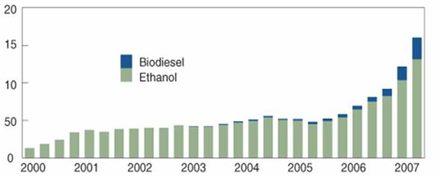

Source: International Energy Agency; FO Licht.

**Bioethanol is used in the following fuels:**

**E10**  
Biofuel consisting of 10% of bioethanol and 90% of gasoline. This fuel is offered e.g. in the U.S. as an alternative to conventional gasoline. It can be used both in the U.S. FFV (Flexible Fuel Vehicles) and vehicles equipped with standard gasoline engines, which have received manufacturer’s authorization to use such fuel.

**E20**  
Biofuel consisting of 20% of bioethanol and 80% of gasoline, offered mostly in Brazil for low-pressure engines.

**E85**  
Biofuel for petrol engines, consisting of 15-30% bioethanol blended with gasoline. The popularity of E85 is still increasing in the world and it is already used widely e.g. in the USA and Brazil. Europe is working on its more widespread deployment, with Sweden in the lead. E85 can only be used in specially adapted vehicles – FFV (Flexible Fuel Vehicles). In Brazil, approximately 80% of all cars sold are FFVs. In Europe, only a few automobile companies offer models designed to use the E85 biofuel.

**E95**  
Biofuel for compression-ignition engines, containing 95% of bioethanol and 5% of gasoline. Due to particularly low level of emissions, this fuel should be used in urban transportation and in protected areas. E95 is a biofuel offered on a small scale. In Europe E95 is used in Sweden.

**E100**  
E100 is offered only in Brazil and Argentina. This fuel is composed of bioethanol with a purity of 99.6% without admixture of gasoline. The remaining 0.4% of the volume is water, which is impossible to be completely separated during distillation.

- in accordance with the directive of the European Commission, accepted by the EU Council and voted in favour in May 2003 by the European Parliament, the share of biofuels in the European fuel market should steadily grow.

**Biofuel market in the EU – legal regulations**

The main legal regulation with respect to the development of the biofuel market for transportation in the EU is the Directive 2003/30/EC of 8 May 2003 on the promotion of the use of biofuels and other renewable fuels for transport, and the EU Council Directive 2003/96/EC of 27 October 2003 on restructuring the Community framework for the taxation of energy products and electricity.

The EU supports the use of biofuels with a view to reduction of greenhouse gas emissions, decarbonation of transport fuels, diversification of fuel supply sources, creation of new sources of income in rural areas and development of sustainable substitutes for fossil fuels. The development trend of production and use of biofuels in EU transport is growing as shown in the Figure 2below.

Figure 2. Comparison of the current biofuel market developemnt trend with the EU Directive 2003/30/EC

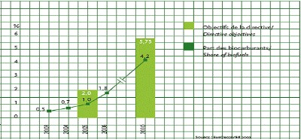

Source: EurObserver: "Biofuels Barometer 2009”

The European Union promotes the use of biofuels or other renewable fuels as a source of energy for transportation. Increased use of biofuels is one of the tools by which the Union can reduce its dependence on imported energy resources (including oil with its constantly increasing prices). Moreover, it may favourably affect the security of energy supply in the future, and is also of paramount importance for the protection of the environment and compliance with the Kyoto Protocol, which obligates the signatories to reduce emissions of greenhouse gases into the atmosphere.

The legal bases for regulating the market of biofuels in the EU are contained primarily in the mentioned above acts:

- **Directive 2003/30/EC** of the European Parliament and of the Council of 8 May 2003 on the promotion of the use of biofuels and other renewable fuels for transport;

- **Council Directive 2003/96/EC** of 27 October 2003 on restructuring the Union framework for the taxation of energy products and electricity.

The above directives form a regulatory framework, which means that member countries are left with some discretion in establishing national norms in this field. EU law regulates only a few significant issues that require implementation in a national law.

The Directive 2003/30/EC introduces the definitions of biofuels, biomass and other renewable fuels. The definitions are:

**‘biofuels’** means liquid or gaseous fuel for transport produced from biomass;

**‘biomass’** means the biodegradable fraction of products, waste and residues from agriculture (including vegetal and animal substances), forestry and related industries, as well as the biodegradable fraction of industrial and municipal waste;

**‘other renewable fuels’** means renewable fuels other than biofuels, which originate from renewable energy sources as defined in Directive 2001/77/EC and used for transport purposes.

The Directive also lists the products which are considered as biofuels: **bioethanol**, biodiesel, biogas, biomethanol, biodimethylether, bio-ETBE, bio-MTBE, synthetic biofuels, biohydrogen, pure vegetable oil.

The Directive obligates the Member States to take measures to gradually increase the share of biofuels in transport. The European Union has assumed that the share of biofuels and other renewable fuels with respect to all motor fuels, will reach the following percentages, starting from 2005:

Table: Percentage of biofuels in the total mass of fuel in the EU Member States

|  |  |  |  |  |  |  |  |
| --- | --- | --- | --- | --- | --- | --- | --- |
| Year | 2005 | 2006 | 2007 | 2008 | 2009 | 2010 | 2020 |
| % | 2.00 | 2.75 | 3.50 | 4.25 | 5.10 | **5.75** | **20.00** |

The target for 2005-2009 was not achieved. The share of biofuels in the total amount of fuel in EU Member States is only 3.4% - only the Germans have managed to achieve the designated cap.

In addition, the Directive 2003/30/EC obligates the Member States to design programs ensuring effective biofuel market development and allowing for public assistance in achieving this goal. Under EU law, it is recommended to establish a list of alternative fuels in each of the EU Member States and to develop quality standards for alternative fuels used in road transport.

**Member States should report to the Commission, before 1st of July each year, on:**

- the measures taken to promote the use of biofuels or other renewable fuels to replace diesel or petrol for transport purposes,

- the national resources allocated to the production of biomass for energy uses other than transport,

- the total sales of transport fuel and the share of biofuels, pure or blended, and other renewable fuels placed on the market. Where appropriate, Member States should report on any exceptional conditions in the supply of crude oil or oil products that have affected the marketing of biofuels and other renewable fuels.

**Biofuel production is quite expensive, therefore EU law allows Member States to apply total or partial tax exemption for biofuels.** This issue is governed by the Directive 2003/96/EC. According to Article 16 of the above Directive, Member States may grant exemptions or reductions in the excise duty for biofuels, but only under certain conditions. Tax incentives for biofuels are treated as state aid and cannot be granted without the consent of the European Commission. The Commission examines whether each public assistance will not cause undue distortion of competition, and whether it is in accordance with the procedures of granting state aid for environmental protection.

It is assumed that public assistance has the sole purpose of compensating the additional costs associated with the production of alternative fuels. Therefore, the Commission verifies whether the state aid granted in the form of exemptions or tax credits to biofuel producers, does not result in undue benefits.

The year 2013 in Poland was the 6-th consecutive year in which fuel producers and importers were obliged to introduce biocomponents and biofuels to the domestic fuel market.

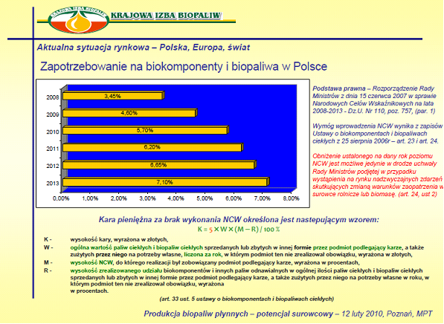

**National Indicative Target, specifying the minimum proportion of biocomponents in fuels and liquid biofuels marketed in 2010 amounts to 5.75% by calorific value.**

In the light of the existing Union legislation it is possible to promote the development of biofuels by supporting the agriculture producing biomass for fuel. Farmers can receive a single direct payment – the Single Area Payment Scheme (SAPS). To be entitled to SAPS, the land must be maintained in good agricultural condition. In addition, payments are allocated to the agricultural land planted with certain crops, e.g. rapeseed, soybean.

Due to diverse climatic conditions in the EU, which require the use of high quality biofuels, and responding to the concerns of car owners, who fear that biofuels will not work well in low temperatures, the European Commission recommended introduction of tax incentives in order to promote biofuels in the Member States. According to the experts, without tax incentives which would be reflected in retail prices, it would be difficult to expect the drivers throughout the EU to use biofuels which contain ethanol.

Therefore a number of EU countries have already prepared plans for the permanent biofuel tax credits. Thus, for example a tax relief granted recently by the Ministry of Finance of Finland for this type of fuel is 30 cents per litre.

The analysts estimate that the production of bioethanol in the EU in 2010 will amount to 6.3 billion litres. The most rapidly growing market for bioethanol is the USA, where every fifth litre of world production of biofuels is consumed.

1. **Due to accessibility of raw materials for production – Poland.**

Poland (42% of rural areas) is one of the few EU countries that have already started producing biomethanol. The production grows every year. Resources of cereals and maize exceed the processing capacity, therefore location of the plant in the rural areas of Great Poland (Wielkopolska) will ensure a supply much larger than the projected requirements for the production of alcohol.

At present approximately 380 thousand tonnes of bioethanol is produced in Poland.  **In the radius of 60-80 km from the plant location specified by the authors, it is possible to purchase the amounts of maize sufficient for long-term contracts.**

Ethanol in Poland is produced mostly by distilleries, which for a number of years now have observed decreasing consumption of alcohol.

## II. Bioethanol – fuel WITH PROSPECTS

Systematic increase in alternative renewable energy sources in the European energy market indicates that by 2030 the EU will have been able to secure more than one fifth of its energy needs from the so-called "clean" sources.

|  |  |  |  |
| --- | --- | --- | --- |
| ***Biofuel*** | ***Plant*** | ***Processing*** | ***Application*** |
| ***Bioethanol*** | cereals (rye, maize), potatoes, sugar beet | hydrolysis and fermentation, preprocessing, hydrolysis, fermentation | substitute and/or gasoline additive |
| *Biomethanol* | energy crops | gasification or synthesis of methanol | fuel cells |
| *Vegetable oil* | rape etc. | -------- | substitute and/or diesel additive |
| *Biodiesel* | rape etc. | esterification | substitute and/or diesel additive |
| *Bio-oil* | energy crops | pyrolisis | substitute of diesel or gasoline |
|  |  |  |  |

Wider introduction of the renewable energy sources to the energy balance of the EU by further development of the bioethanol market, will however require a new definition of standards for environmental protection, which will take into account the quality of the fuel used.

**Production of gasoline with biofuel is subject to excise duty reliefs.**

Bioethanol is already added to gasoline in small quantities e.g. - wodór wytwarzany z wykorzystaniem odnawialnych źródeł energii (słonecznej, wiatrowej oraz biomasy) i zasilający ogniwa paliwowe napędzające pojazdy (w perspektywie długoterminowej).

W perspektywie krótkoterminowej ze względu na istniejącą sieć dystrybucji paliw najprostsze jest wykorzystanie:

• oleju rzepakowego – przetworzonego na metylowy ester rzepakowy, który może być stosowany w czystej postaci w przystosowanych pojazdach (Niemcy, Austria i Szwecja) lub mieszany z konwencjonalnym olejem napędowym w ilości do 30% dla wybranych grup pojazdów (Francja, Czechy) albo w ilości do 5% w powszechnie stosowanym paliwie do silników wysokoprężnych (Francja i Włochy). Ponadto ester ten może być stosowany zamiast oleju opałowego lub jako dodatek do tego paliwa, czego przykładem jest ogrzewanie nowej siedziby Parlamentu Niemiec.

• alkoholu etylowego, który może stanowić komponent benzyn lub być stosowany jako paliwo w czystej postaci (bioetanol). Większość pojazdów może korzystać z paliwa z 15% dodatkiem etanolu bez żadnych modyfikacji silnika.

Ważnym elementem prac nad szerszym stosowaniem biopaliw w UE jest standaryzacja. Obecnie w fazie końcowej są prace nad normą europejską dotyczącą biodiesla (projekt normy PrEN 14214) „Automotive fuels – Fatty acid methyl esters (FAME) for diesel engines – Requirements and test methods). Przyjęcie ostatecznej wersji normy oczekiwane jest przed końcem 2002 r.

Zachwianie dostaw ropy w latach 70-tych i w czasie wojny w Zatoce Perskiej zbiegło się z nadprodukcją rolniczą w Europie. Te dwa elementy stały się siłą napędową rozwoju wykorzystania surowców roślinnych na cele przemysłowe, w szczególności przetwarzania na paliwa płynne. Przemysłowa produkcja biopaliw rozwinęła się w krajach UE mających z jednej strony nadprodukcję rolniczą, z drugiej strony wysokie opodatkowanie paliw kopalnych. Taka sytuacja wpłynęła na świadome ograniczanie produkcji surowców żywnościowych na rzecz surowców przemysłowych, w tym energetycznych. Obecnie głównym argumentem motywującym działania w tym zakresie jest zaniepokojenie globalnym i lokalnym zanieczyszczeniem środowiska. Transport jest dynamicznie rozwijającym się sektorem, praktycznie w 100% zależnym od ropy naftowej. Równocześnie sektor ten ma coraz większy udział w zanieczyszczaniu atmosfery - emisje CO2 z transportu rosną systematycznie. Świadomość tych faktów znalazła odbicie w przyjętej we wrześniu 2001 r. przez Komisję Europejską Białej Księdze dotyczącej transportowej polityki UE do 2010 r. oraz wpłynęła na przyjęcie w listopadzie 2000 r. tzw. Zielonej Księgi UE dotyczącej strategii europejskiej w zakresie bezpieczeństwa energetycznego COM(2000)769. Zielona Księga zakłada 20% udział alternatywnych paliw w sektorze transportu drogowego w roku 2020 jako element poprawiający bezpieczeństwo energetyczne poszerzonej UE oraz redukujący emisję gazów szklarniowych..

Komisja Europejska dostrzegła trzy potencjalne obszary paliw alternatywnych, które mogą osiągnąć udział 6-7% do 2010 r. i do 20% do 2020 r. w rynku paliw pędnych, a mianowicie:

- biopaliwa ciekłe w postaci bioetanolu, ETBE i biodiesla (w okresie najbliższych 5 lat) oraz olejów pirolitycznych,

- gaz ziemny (w średniookresowej perspektywie),

- wodór wytwarzany z wykorzystaniem odnawialnych źródeł energii (słonecznej, wiatrowej oraz biomasy) i zasilający ogniwa paliwowe napędzające pojazdy (w perspektywie długoterminowej).

W perspektywie krótkoterminowej ze względu na istniejącą sieć dystrybucji paliw najprostsze jest wykorzystanie:

• oleju rzepakowego – przetworzonego na metylowy ester rzepakowy, który może być stosowany w czystej postaci w przystosowanych pojazdach (Niemcy, Austria i Szwecja) lub mieszany z konwencjonalnym olejem napędowym w ilości do 30% dla wybranych grup pojazdów (Francja, Czechy) albo w ilości do 5% w powszechnie stosowanym paliwie do silników wysokoprężnych (Francja i Włochy). Ponadto ester ten może być stosowany zamiast oleju opałowego lub jako dodatek do tego paliwa, czego przykładem jest ogrzewanie nowej siedziby Parlamentu Niemiec.

• alkoholu etylowego, który może stanowić komponent benzyn lub być stosowany jako paliwo w czystej postaci (bioetanol). Większość pojazdów może korzystać z paliwa z 15% dodatkiem etanolu bez żadnych modyfikacji silnika.

Ważnym elementem prac nad szerszym stosowaniem biopaliw w UE jest standaryzacja. Obecnie w fazie końcowej są prace nad normą europejską dotyczącą biodiesla (projekt normy PrEN 14214) „Automotive fuels – Fatty acid methyl esters (FAME) for diesel engines – Requirements and test methods). Przyjęcie ostatecznej wersji normy oczekiwane jest przed końcem 2002 r.

by Rafineria Gdańska. Although it has been blended since 1998 - in 2001 its 5% admixture was present in as much as 57% of petrol sold at RG gas stations in Poland, there has been not a single complaint. Cars powered by the fuel with additives of bioethanol and esters have made hundreds of thousands of kilometres throughout the world.

In Poland, the requirements first adopted by PKN Orlen for ETBE are being implemented. Data from the Ministry of Finance shows that already in 2001, 17.43% of gasoline sold in Poland contained 4.5% of bioethanol.

1. **Obtaining biofuels:**

**Biofuel** is a renewable energy source derived from vegetable products. In practice, it is possible to obtain two main types of biofuels: alcohols, namely **bioethanol** and biomethanol, and oils. We are interested in the production of ethanol, and then dehydrated bioethanol.

- **ethanol** is both very cheap to produce and relatively harmless to the environment, therefore it is commonly used as a solvent in the chemical industry.

Consumable **ethanol** is derived by fermentation of sugars. The source of sugars is usually cereals (rye, wheat, maize, barley) as well as potatoes and agave. Consumable ethanol is a fundamental component of all alcoholic beverages. **Bioethanol** is a dehydrated raw spirit. To use **ethanol** as a fuel ingredient it must be **dehydrated** (water content below 0.02%).

**Ethanol dehydration can be performed using the following methods:**

* azeotropic distillation with cyclohexane;
* using molecular sieves (MS);
* [membrane pervaporation technique (PV).](http://www.its.hg.pl/pv.html)

**BIOEThANOL – Katzen method.**

Poland started to gain experience in the production of bioethanol with launching a spirit dehydration installation in 1950. However, a more dynamic development of bioethanol production has begun in Poland since 1993. Practical experience with various technologies of production of ethanol clearly shows that the best and proven technology is the one developed by **R. Katzen Associates International Incorporated**, located in Cincinnati, Ohio, United States.

**Bioethanol** is one of the basic and most popular biofuels in the world. It corresponds to the so-called “ideal fuel” which on combustion in the engine cylinder emits into the atmosphere carbon dioxide, graphite and water. Already Henry Ford, while designing the famous Ford Model T, predicted that it would be powered by ethanol.

In the USA it is allowed to use gasoline with either 10% ethanol additive or the E85 fuel, which contains 85% of ethanol. Ford and Chrysler produce engines adapted for this type of fuel (such as Ford Taurus, Ford Ranger Pickup, 3.3L Chrysler Minivan).

***The following points support the use of bioethanol as a fuel:***

* Each unit of heat used to produce ethanol results in **eight** times more energy contained in plain ethanol. Production of ethanol is considered to be the most effective method of obtaining traction fuels;
* Ethanol is a renewable fuel that can be derived from many agricultural products;
* Production and combustion of ethanol does not increase the greenhouse effect;
* Ethanol has a high octane number and low price, which makes it the best additive to increase octane number of gasoline;
* Mixtures of ethanol can be used in all types of engines;
* Ethanol is biodegradable without serious impact on the environment;
* High oxygen content of ethanol lowers the level of carbon monoxide in exhaust gasses, much more than other oxidants used as additives to gasoline (according to the EPA by about 25%);
* Adding ethanol to gasoline reduces emissions of nitrogen oxides by about 20%;
* Adding ethanol to fuels effectively reduces emissions of unburned hydrocarbons, which positively affects the Earth’s ozone layer;
* Mixtures with high levels of ethanol can reduce emissions of volatile organic compounds by about 30% (they are responsible for the formation of ozone layer on the Earth.);
* As an additive to increase octane number, ethanol can reduce emissions of carcinogens by more than 50%;
* Emissions of sulphur oxides and particles fall sharply in the case of adding ethanol to fuel;
* Ethanol can be used as raw material for the production of Ethyl Tert-Butyl Ether (ETBE), which is considered as a very good and safe supplement to gasoline, equally effective in improving its quality.

## III. Statistics and EU documents on the liquid biofuels – development

**Work on biofuels in EU - facts and statements:**

* 0.15% (about 1 million tonnes) of liquid biofuels in the EU's balance of liquid fuels in 1998 and 0.36% in 2000 (EUROSTAT),
* 5 million tonnes of biofuels in 2003 (EU Implementation Campaign '99),
* A minimum of 2% of biofuels in 2005 and 5.75% of biofuels in the balance of liquid fuels in 2010 – the quantitative targets of the "EU biofuel" Directive,
* 7% in the balance of liquid fuels in 2010 and **20%** in 2020 (the political objective of the White Book ‘97 and the Green Book '2001).
  1. The original target for the production of liquid biofuels, as defined in the so-called White Book, was the level of 18 million tonnes (taking into account the liquid biofuels not produced from energy crops but for example from wood pulp, waste oils from restaurants and biogas as fuel). This corresponds to 5% of energy consumption in transport in the base scenario for the period to 2010.

**B.)** In response to this obvious need, and obliged by the guidelines of the European Council, the European Commission prepared a proposal for a Directive aimed at propagation of use of biofuels in transport (“**Directive of the European Parliament and of the Council on the promotion of the use of Biofuels for Transport**”). The Directive establishes a minimum percentage of consumption of conventional fuels, which is to be replaced with biofuels in each Member State. Up to 2020 the use of biofules in transport must be 20% on the EU and 15% in Poland.

**The Directive defines:**

* ‘**biofuels**’ means liquid or gaseous fuel for transport produced from biomass;
* ‘**biomass**’ means the biodegradable fraction of products, waste and residues from agriculture (including vegetal and animal substances), forestry and related industries, as well as the biodegradable fraction of industrial and municipal waste;
* ‘**energy content’** means the lower calorific value of a fuel.

**The products listed below shall be considered as biofuels:**

Bioethanol, Biodiesel, Biogas, Biomethanol, Biodimethylether, Biooil, BioETBE - ETBE produced on the basis of bioethanol.

**C.)** The Directive states that Member States should ensure that the minimum proportion of biofuels in the national market for transport fuels (petrol and diesel) is 5.75% according to the criterion of energy contents by the end of 2010 and then increased so as to achieve by 2020 “a minimum level of blending” of 20% in the EU and 15% in Poland.

According to the European Commission, biofuels should be available in two forms:

* pure biofuels,
* biofuels blended with crude oil processing products, as liquids derived from biofuels such as ETBE.

**Priorities of the EU’s Sixth Framework Programme** - 6.1. “Sustainable Energy Systems”.

***Alternative fuels for transport:***

* **OBJECTIVE: 20% share of alternative fuels** for transport fuel market in 2020.
* Research and Technology Development (RTD) activities focused on three types of fuels: biofuels, natural gas and hydrogen.
* Integration of fuels with transport systems, especially in urban areas.
* Improvement of economic profitability and safety of production, storage and distribution, including:
* increase of profitability of production of biofuels based on various agricultural raw materials,
* reduction of production costs of raw materials (currently 60-80% of biofuel cost).
* RTD activities should focus on developing sustainable biomass-energy processing chains, and in particular:
* reduction of the cost of energy from biomass by 15-20% (heat, electricity), or 30-50% (liquid biofuels).
* The activities of the European Commission and the EU present an integrated approach to solving problems of energy security and the growing emissions in transport, without preference and one-sided support of specific solutions.
* Since the biofuel production costs are in general higher than the prices of fossil fuels, increased use of biofuels can be achieved only by subsidizing the production of raw plant materials and/or active fiscal policy supporting implementation of renewable energy sources.
* Market solutions should be implemented gradually, e.g. through projects demonstrating local organizational solutions, allowing initial reduction in investment risk and even distribution of risk and profits among raw material suppliers, manufacturers and consumers.

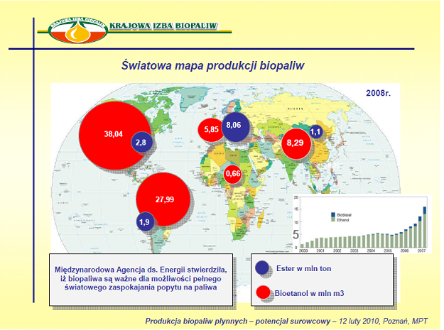

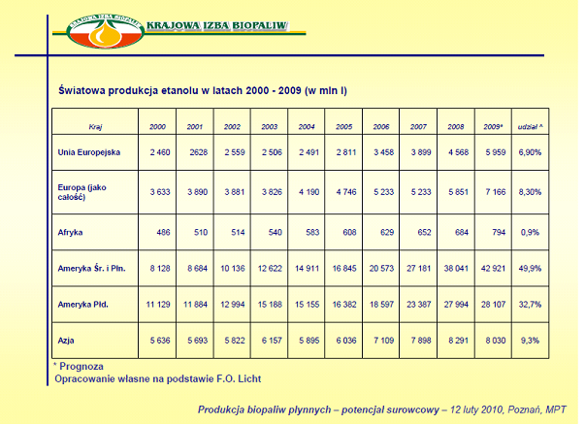

There are various technical possibilities of use of bioethanol as a fuel, from the use as a separate fuel to a blend with gasoline in various proportions. From the point of view of agricultural producers, it is especially important that various components of gasoline can be relatively easily replaced with their biocomponent counterparts. According to experts, the best raw materials for bioethanol production in Europe are sugar beets and cereals especially wheat and rye, as well as maize. Therefore, although the efficiency of production of bioethanol from sugar beet is more than twice as high as from wheat, due to large quantities of raw material needed for this project, both these varieties of agricultural crops are taken into account. Experts already state that this may have very important implications for future situation on the EU cereals market, if already in 2010 approximately 4 million tonnes of wheat and rye were allocated for the production of bioethanol.

Technological tests carried out by the Sugar Group Pfeifer & Lange indicate that production of bioethanol using other raw materials like potatoes is not very profitable because it is too expensive.

It is important to note that Ford and Saab have already introduced engines, which automatically recognize the composition of fuel and adjust their operating parameters to the contents of bioethanol.

The draft of a Directive on the use of biofuels as an additive to gasoline and diesel, which has been under discussion since 2001 , assumes a gradual increase in the share of biofuels to 5.75% up to 2010 and to 20% in 2020. Poland has been granted special permission to have this level at 15% .

Virtually every EU country uses biofuels, although the situation varies greatly. Austria and France are the most active countries in the implementation of biofuels, but it is **France, which is today the European leader in the production of bioethanol converted into ETBE and added to gasoline.**

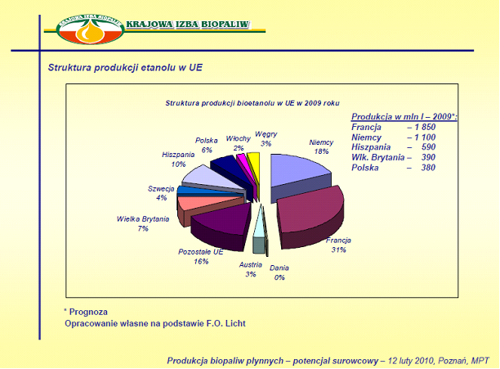

In Germany, biofuel is not subject to excise duty. In Austria pure biofuel as well as 5% mixture with gasoline and up to 2% mixture with diesel is exempt from excise duty. However, mixtures with higher content of bio-fuels are taxed like normal fuels. In Great Britain, Denmark and Belgium there are no preferential duty rates for biofuels.

In the central part of the United States gasoline blended with 10% ethanol (E10 gasohol) is on sale. Ethanol is sometimes used in the U.S. as ETBE, and this form is preferred by the World Fuel Charter.

* 1. **Investment: production of dehydrated and rectified spirit**

## I. Assumptions.

The intention of the Investor is to launch production of alcohol based on rye, maize and spirit, which will be further processed and converted to dehydrated alcohol (ethanol) and rectified spirit (alcohol for consumption and for pharmaceutical and cosmetic purposes).

The production plant will have a capacity of 125 million litres of raw spirit, which will be converted to:

* 105 000 000 litres of dehydrated spirit (bioethanol),
* 20 000 000 litres of rectified spirit (consumption spirit).

Additional product offered for sale will be granulated fodder, which is a derivative of spirit and an ingredient for animal feed production. It is expected that production of the feed ingredient, assuming production of 125 million litres of spirit, will amount to 115.5 thousand tonnes.

1. Raw materials for production of spirit.

**The economic efficiency of the technological process is very important to the outcome of this project.**

Therefore, we present here the difference between sugar beet and potato (which are universally recognized as the best for the production of spirit), and rye and maize:

**1.) 1 ha of sugar beet can yield,**

more ethanol, but a much greater mass of raw material must be subjected to fermentation, increasing the cost of alcohol production.

**2.) The figures presented in** Table **1**

clearly indicate to maize as the most efficient raw material for ethanol production (per unit of crops).

|  |  |  |  |  |  |
| --- | --- | --- | --- | --- | --- |
| Table 1. Efficiency of ethanol production from different crops (IUNG Pulawy) | | | | | |
| Plant | Contents of starch or sugar  (%) | Ethanol yield  (l/t) | Crops (t/ha) | Ethanol (l/ha) | Gasoline equivalent  (l) |
| Maize | 65.0 | **417** | 8.0 | 3336 | 2234 |
| Sugar beet | 16.0 | 98 | 45.0 | 4410 | 2953 |
| Potato | 17.8 | 120 | 16.0 | 1920 | 1280 |
| Rye | 62.0 | **390** | 2.8 | 1092 | 730 |

**3.)** The arguments for processing maize, **apart from rye,** to obtain ethanol are:

* An increase in the farming area used to grow maize for grain and a corresponding increase in its yield (the trend is constant in recent years) will lead to saturation of the Polish market with feed maize, and the resulting overproduction will need to be managed to prevent too large drops in grain prices,
* Use of maize grain for other purposes than fodder will balance the market and will prevent large fluctuations in price,
* The grains which are not suitable to produce fodder, i.e. infected with fungi, cracked, unripe or wet, can still be used for production of ethanol,
* Production of ethanol from maize is safer for the environment than from sugar beet, not to mention potatoes. When processing sugar beet and potatoes much more waste is produced, which needs to be recycled.
* Waste remaining after fermentation of maize can be fully exploited and does not represent environmental risk.

**4.) Yield of ethanol from maize,**

compared to wheat is as follows:

|  |  |  |  |  |
| --- | --- | --- | --- | --- |
| **Raw material** | Crops in 2009  according to GUS[1] dt/ha | Alcohol yield l/dt | Alcohol production l/ha | Raw material per 100 l of ethanol |
| **Maize**  Wheat | 61  35 | 37  34 | 2257  1190 | 270  295 |

**5.)** In this project maize, and rye, will be the basic raw materials for production of spirit, because of their high yield and late harvest, which allows better use of the production line.

**6.) Rye in the free market conditions**

is usually much cheaper than wheat, barley, maize and sorghum. The lower price of rye is caused not only by limited consumer demand (rye bread is only popular in some countries), but mainly by lower feed value when compared to other cereals. As a result, the turnover of international rye trade is negligible when compared to wheat, barley and maize.

**7.) High intervention price of rye**

has resulted in recent years in an increase in intervention stocks, which are clearly structural and impossible to accommodate in international markets. High costs of intervention (including storage costs) have been raising concerns of many EU countries, and in particular the ones not interested in intervention.

**8.) Rye is grown on a larger scale only in Austria and Germany,**

but its importance to the cereal economy of these two countries is incomparably lower than in Poland (in Germany it is grown primarily in the eastern states).

EU's decision to abandon the intervention causes a decline in market prices of rye.

**Therefore in our conception, rye together with maize will be the basic raw material for the bioethanol production plant in Witaszyce.**

**CONCLUSIONS:**

**1.) Rye is currently the most economically effective raw material** for production of ethanolin terms of available amounts and yield from unit area.

About 11 million ha of rye is grown worldwide, which is about 1.5% of the area of all cereals. Major producers are: Russia, Sweden, Poland, Germany and Belarus. In Poland, **rye** is grown on about 2350 thousand hectares, which represents over 26% of all cereals. On average about 23 quintals of grain per hectare is obtained.

5500 thousand tonnes of grain is produced in Poland on average every year, which amounts to about 23% of global harvest.

**2.) Maize is the second best raw material,** as 37 litres of alcohol can be obtained from 1 dt (wheat - 34 l, potatoes - 14 l, sugar beet - 10 l) and indeed the average maize yields are much higher (in Poland in a normal year like 2009, yield of maize was nearly 61 dt compared to 35 dt of wheat per 1 ha).

**3.) Our alcohol production will additionally be based on maize,** as this also produces dried stock which can be used for feeding of cattle, pigs and poultry (confirmed by studies of the National Institute of Animal Production in Cracow). Half of the dried stock will be handed over as raw material to the biogas-plant that will provide electric power and heating.

**4.) The raw material (rye, maize) is a key factor in the final price of bioethanol** and for that reason in the following sections we will focus on the forecasts and possible stabilization of the rye and maize markets in the EU and Poland.

Available data show that the basic element of the manufacturing cost of bioethanol from plant biomass is the price or cost of raw materials (such as rye, maize).

**Raw material determines the bioethanol production cost in 60-80%.**

III. Analysis of raw material prices.

**1.) Finally confidence and stabilization on the grain market.**

Seasons 2009/10, 2010/11, 2011/12 are the seasons of grain overproduction.

**2.) What is more important, the grain prices have stabilized or decreased.**

**3.) Previously, farmers and commercial grain customers were not sure how the situation would develop.**

Earlier, each year the Government used to fix amounts to be spent on additional payments to producers of grain and the rates that farmers were to receive. This action started at different time every year and only selected agents were able to participate in it. High prices usually applied to 5 million tonnes of grain per year (about one quarter of total production) and were granted on the first come, first served basis.

**4.) Estimates for this year’s crops – more grain.**

Estimates for the agricultural crops in 2009, 2010, 2011, 2012 made by the experts from GUS (Main Statistical Office) indicate considerably better grain yields than before. Our statisticians estimate the harvest of basic cereals and cereal mixes at 25-25.9 million tonnes, which is about 16 to 21% more than in the earlier years.

**CONCLUSION:**

This is good news for our investment in Witaszyce as the Plant will be secured with large amounts of raw material at low price.

### Rye and maize prices in Poland to 2015.

**Currently the prices of basic cereals on the Polish market are mostly similar to the current prices on comparable markets of the EU** (eastern part of Germany).

Polish rye and maize, according to the experts will always be priced below the prices of OECD and EU average, **which places our investment in a very good situation.**

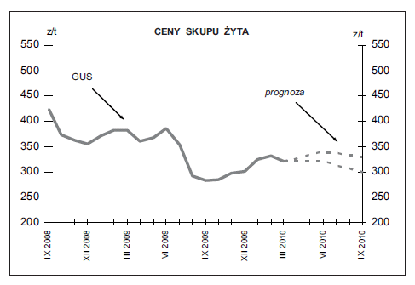

**RYE PURCHASE PRICES**

*forecast*

**Current purchase price of maize – approx. 110 euro/t (435 PLN/t).**

Particularly low prices were recorded in Central and Eastern Europe. At that time in Poland, prices of these cereals were 1-3% lower than the EU average.

1. **In the current season** the grain balance of Poland and EU, as well as of key international markets, is of crucial importance for the market situation.

The year 2009 brought record-breaking grain harvest, 2.6 million tonnes greater than the estimated domestic consumption in the 2009/2010 season. According to the evaluation of GUS, in 2009 29.8 million tonnes of cereals were harvested, that is 7.8% more than in very good year 2008, and 11.5% more than the average in 2001-2005. In the years 2010/11 and 2011/12 the harvest data were similar to those of 2009. The prices, however, went up.

1. **According to recent forecasts cereal harvest in the years 2010-2015 may be higher by dozen or so percent as compared to the previous years.**
2. **The EU production will grow similarly.** The world leading cereal suppliers, especially Ukraine and Russia, will increase their export. Both these countries in 2008, 2009, 2010, 2011 and 2012 demonstrated the fastest increase in supply to the EU market (mainly feed wheat). In a year of good harvest, they are able to offer feed wheat at prices ranging up to 80-100 USD per tonne for almost whole season. And it is the feed wheat which will not be subject to intervention on the Polish market and thus will be most vulnerable to price falls in the final months of the year.
3. **Polish producers can count on the export support with EU subsidies**
4. **Sales of Polish cereals to the markets of other EU countries may also have some significance.** However, with the prices already levelled, the barrier may be the quality of grain offered and the decisions of potential importers, who will be able to choose between importing feed or the final products (livestock, meat and milk).
5. **An overall decrease in grain prices will also be inhibited** by good conditions on the breeding market, where the Polish accession to the EU has brought about a rapid increase in prices and in demand for Polish products. This is confirmed by signals from the sector of poultry and pork.

For the Investor this is a good signal in view of production of substantial part of ethanol from rye and maize, which generates fodder as a highly profitable by-product.

1. **Of great importance for the movement of prices on the Polish cereal market** will be the exchange rate of Polish currency**. Strong Polish currency will encourage reduction in prices, hampering export of both cereals and livestock products. It may also be an incentive for the importers.**
2. **The below forecasts apply to the prices paid to the producers,** assuming:

* Average PLN/EUR exchange rate of 3.9 – 4.1
* Cereal harvest in 2011-2017 will not deviate from long-term average by more than 5%.

### Situation ON the global cereal market to 2015.

#### Production of cereals in the world and its changes

Global trends in cereal production as shown in vary in range and pace. Maize yield increased rapidly in the years 1961-1980 by 2.7% per year on average, while in the years 1981-1990 only by 1.5% per year.

In the years 1991-2000, the increase in the maize harvest again reached 2.6% per year. Rye and oats harvest in 1960-2000, however, showed a downward trend. Overall, nevertheless, in the analysed periods an increase in the harvest of wheat and maize was greater than the decrease in the harvest of rye and oats, which resulted in an increasing trend in the total cereal harvest.

Significant variations shown in Figure1 below are caused by changes in the level of consumption, stock and prices.

Figure 1. Worldwide cereal harvest in 1960–2000

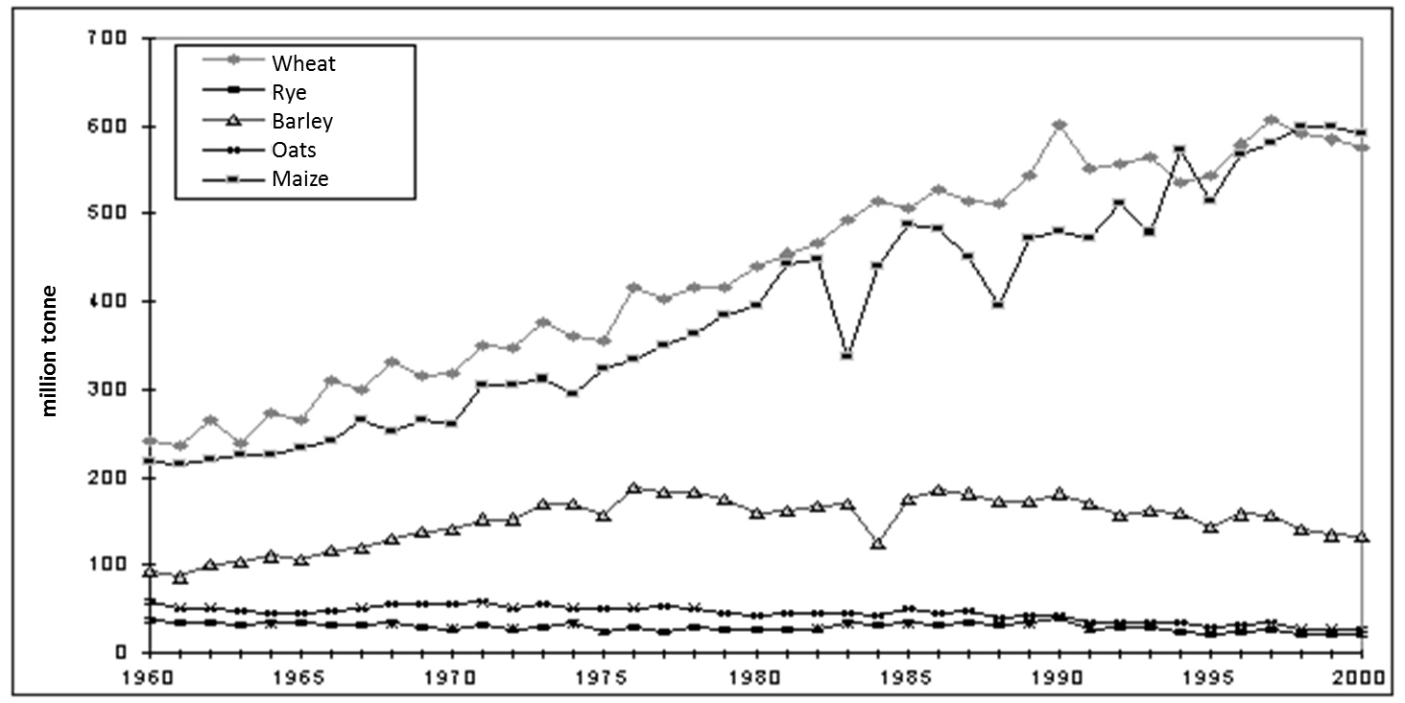

Source: GUS

#### Cereal prices on the world markets

Figure 2. Evolution of the global HRW wheat prices in the years 1981/82 - 2000/01 - 2005/06 (USD/t)

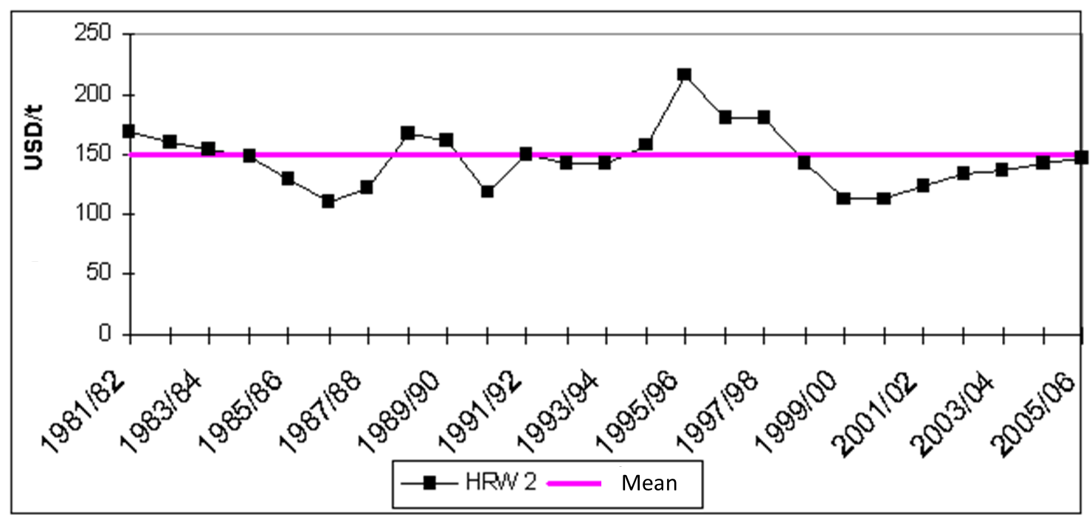

Figure 3. Evolution of the global SRW wheat prices in the years 1981/82 - 2000/01 - 2005/06 (USD/t)

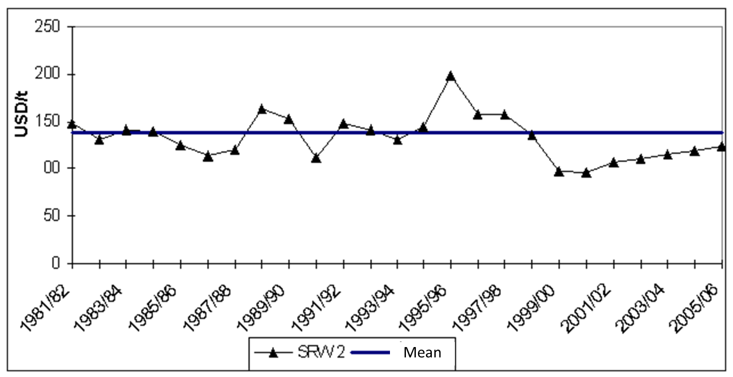

Figure 4. Evolution of the global maize prices in the years 1981/82 - 2000/01 - 2005/06 (USD/t)

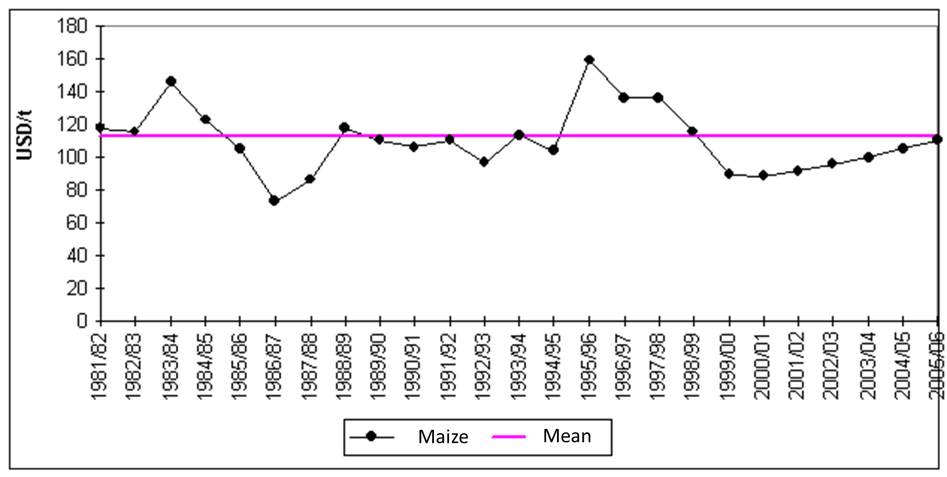

#### Forecasted cereal prices on world markets in the next years

Considerable differences in regional demand for cereals are expected. In the developing countries the rate of growth of demand may be higher than the growth rate of production.

The European Commission predicts the following changes in cereal production:

* increase in cereal yields from 5.7 t/ha in 2000 to 6.1 t/ha in 2012; the yields of maize, wheat and rye are to grow most rapidly,
* in the years 2006-2014 cereal harvest in the EU could increase by 13.0% to 226.5 million tonnes.

As a result of these changes the possibilities for export of cereals from EU countries will increase. In other countries, which are traditional exporters of cereals, an increase in production is expected. The increase in demand for cereals will on the other hand come mainly from countries that are their traditional importers. As a result, trade flows on the cereal market will increase. It will also be one of the main factors influencing their prices.

**For this reason, only a small nominal increase in grain prices on world markets is possible.**

According to the projections shown, there are no factors that would increase grain prices on world markets in the medium term. Despite a small nominal increase, in the medium term the prices will remain below the long-term average. This has been shown in the figures above. A maximal average annual price growth rate within 1.8 - 2% is a reasonable assumption.

The considerable fluctuations around the mean are due to the influence of natural and climatic factors on the grain harvest, and consequently on their supply. In the years 1981-2000 a 1% decrease in harvest resulted in an average increase in the price of wheat by 6-8%. Good harvest in the coming years, e.g. increased by 3%, may cause a drop in prices by 6-9%, to the level of 116-120 USD/ t, similarly to the 1999/2000 season.

Analysis of price changes in the domestic and global markets demonstrates certain regularities, like high variability of the prices in both markets and similar direction of changes. **This implies correlation between the prices in Poland and in the global markets, however with different strength.**

Until mid-1996 the coefficient of correlation between domestic and global monthly wheat prices amounted to *r* = 0.754. Until mid-1999 the correlation considerably increased (*r* = 0.9327), strengthening the link between the prices. In the years 1999-2001 however, the correlation coefficient diminished to *r* = 0.4163.

Figure 5. Prices of cereals on the global and Polish markets in the years 1990-2001 (USD/t)

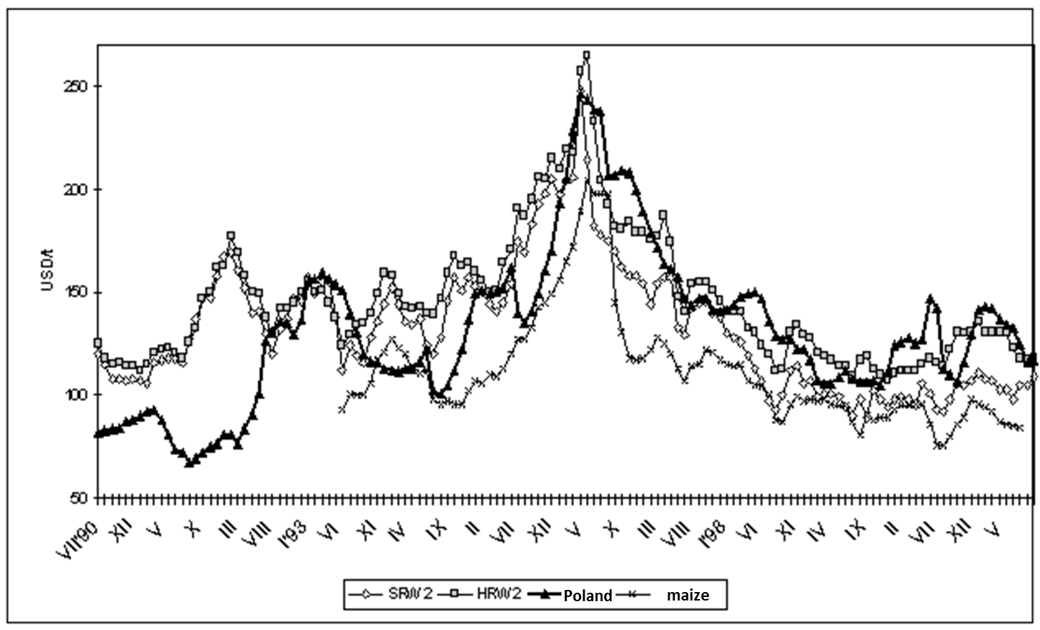

Progressing processes of integration of economies, opening to the world, increasing importance of international trade, progressive liberalization processes as well as the increasing role of international agreements, will result in strengthening the link between the Polish and global markets.

**This means that the trends in cereal prices in Poland, taking into account the trade liberalization, may resemble the ones in the global market.**

In the medium term a modest nominal increase of the prices is possible. The prices in the domestic market will also be influenced by the currency exchange rates - weakening of the Polish Zloty (PLN) will favour increase in prices, while its strengthening will most likely cause a decline in cereal prices.

The export potential of the Central and Eastern European countries is also of great importance in shaping the grain prices in Poland. It is possible that in these countries the grain production will increase beyond the level of internal demand. In this case, the proximity to supply sources and lower transport costs may weaken the upward pressure on grain prices in Poland in both the short and medium term.

#### Prospects of cereal prices in the EU and OECD.

*The text below comes from the OECD Agricultural Outlook: 2010-2019 available at* [***www.oecd.org/bookshop/***](http://www.oecd.org/bookshop/)***.***

**Market situation**

The economic downturn had direct consequences on biofuel markets. From mid-2008 to mid-2009, weaker energy prices caused a reduction in profit margins of biofuel plants which together with the financial crisis delayed private investments around the world. This, associated with reduced policy support for biofuels in some countries and concerns’ regarding the sustainability of biofuel production has contributed to a slow down in the pace of expansion of the industrial capacity of the sector. When compared to their peak 2008 levels, ethanol and biodiesel prices decreased, respectively, by 6% and 26% in 2009.

Since the second half of 2009, the return of stability in mineral oil prices and the enforcement of higher biofuel blending obligations in some countries have triggered an acceleration in demand for ethanol and biodiesel and subsequently for feedstock used to produce biofuels. It has contributed to the recent strengthening in world prices for ethanol and biodiesel.

**Projection highlights**

**1.)** The implementation of policies calling for growing ethanol use means that global ethanol production is projected to increase by more than 110% over the projection period and to reach some 159 billion liters

Global ethanol production to grow by more than 110%

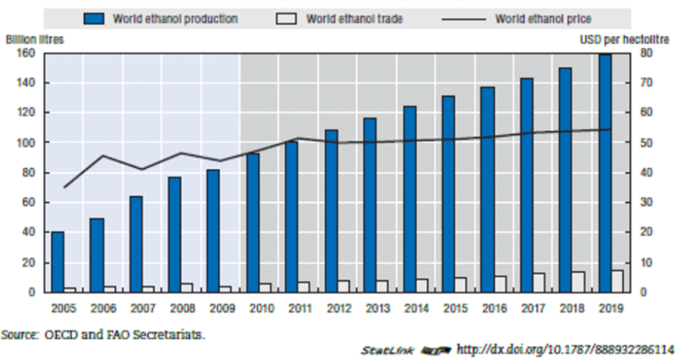

1. Because of increasing mandates and consumption incentives, global biodiesel production is also expected to increase to almost 41 bnl by 2019 far above the average 2007-09 level

Global biodiesel markets to continue to expand

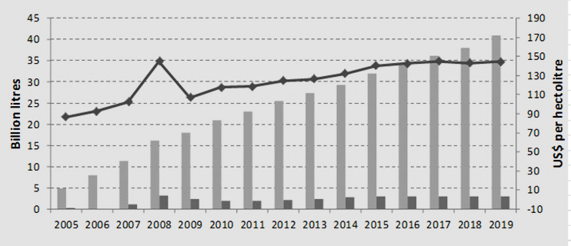

1. The US is expected to remain the largest ethanol producer and consumer according to the Agricultural Outlook.

Ethanol markets dominated by the US, Brazil and EU

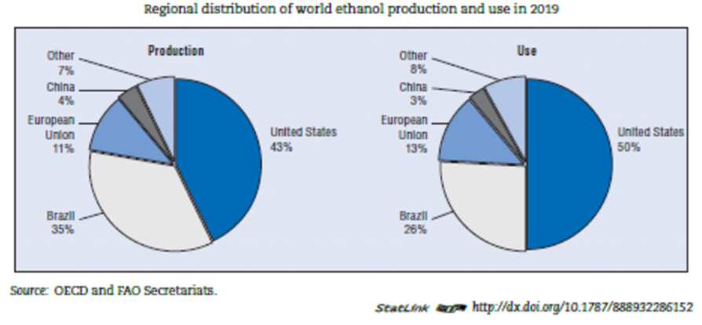

1. Brazil with its sugarcane based ethanol industry should be the main exporter. Part of Brazilian ethanol exports are expected to be channeled through Caribbean countries into the US to take advantage of preferential import conditions.

5.) With forecasted 60% of global biodiesel use in 2019 the EU will remain the largest biodiesel market in the world. Other countries, notably India, the US and Brazil are set to reach substantial biodiesel use level as well.

1. Regional distribution of world ethanol production its and use in 2018

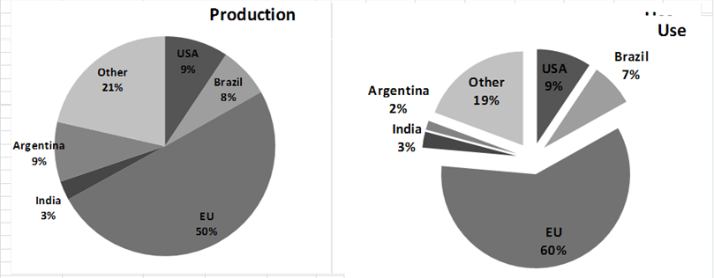

Biodiesel is expected to be only little traded as most countries with consumption programs produce their biodiesel domestically. Nevertheless Argentina should remain the major exporter with exports reaching a stable plateau after 2015.

**World markets at a glance**

As was correctly anticipated in last year’s *Agricultural Outlook*, international market prices for most agricultural products retreated considerably in 2009 due to a strong production response and lower demand caused by the recent high prices and the onset of the global recession. In a context where energy prices remain generally high by historical standards and are expected to rise further with global economic recovery that is underway, the Outlook projects that most crop prices will remain at or above 2010 levels in the longer term. These will continue to exceed, in nominal and real terms (once adjusted for inflation), the average price levels in the decade preceding the price hikes of 2007/08. Apart from pig meat, this is also true for livestock prices which in real terms have remained above the average levels for the last decade.

Figure. Nominal commodity prices remain above average levels compared to previous decade but lower than 2007/08

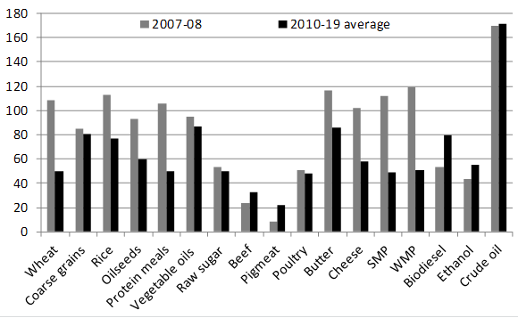

Most prices of raw materials, in real terms, remain on the level higher than in the last decade

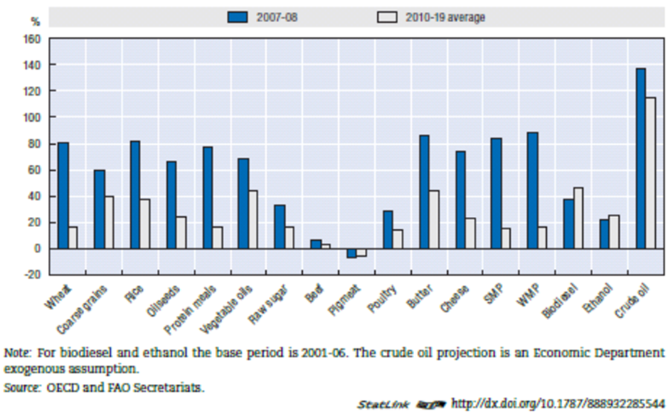

Overall, it is expected that nominal prices of all commodities included in the programme will be on a higher plateau over the projection period, 2010 to 2019. However they will tend to remain below the peak levels of 2007/08. In the case of wheat, rice, protein meals, cheese and skim milk powder, average prices over the projection period will be around 50% or more below the peak levels reached in 2007/08. As some commodities, such as sugar, beef and pig meat did not undergo the same rapid run up in their prices in 2007/08, average nominal prices for the decade ahead will be about the same or will exceed the levels of 2007/08 by 10-20%.

For the entirety of agricultural products covered by this programme the average nominal prices over the projection period will exceed those of the previous decade prior to the period of peak prices. These price gains are expected to be highest for vegetable oils and butter at over 85% above those achieved in 1996-2006. Of the products at the lower end of the nominal price increase scale, pig meat prices will show the smallest increase, rising on the average by just over 21% above the 1997-2006 average level, over the period to 2019.

The evolution of ethanol production from feedstock over the projection period is presented in the below table.

Evolution of biodiesel production from feedstock over the projection period

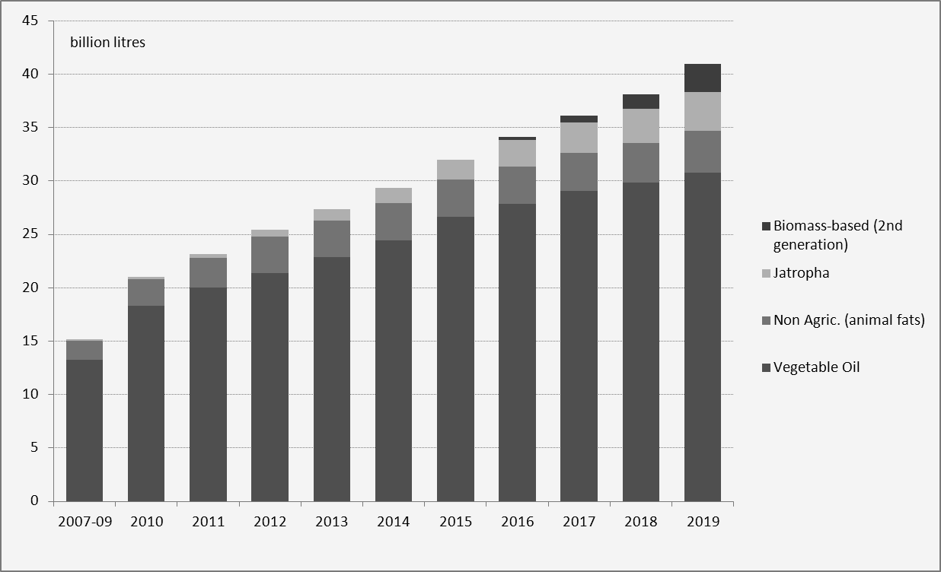

It shows that the major feedstock for ethanol production should remain coarse grains all over the projection period. The use of coarse grains for ethanol production should grow relatively more slowly after 2015 when the mandate for Conventional Renewable Fuels reaches its maximum.

**Biomass based second generation ethanol is only expected to develop in the latter years of the projection period, representing about 7% of total ethanol production.**

Roots and tubers and molasses are expected to be used as feedstock for ethanol production in developing countries.

**Wheat, coarse grains and sugar beet should be used in the European Union to produce ethanol.**

The share of the different agricultural commodities used for ethanol and biodiesel production (molasses, vegetable oil, coarse grains, sugar beet, wheat and sugarcane) in global production is expected to increase strongly over the projection period

It shows that edible vegetable oil is expected to remain the major feedstock used to produce biodiesel. However its share in total biodiesel production should decrease from almost 90% over the base to about 75% by 2019. This is due to the development of the production of biodiesel based on *jatropha* mainly in India, to the increasing use of animal fats to produce biodiesel in the US and to the availability of biomass based second generation biodiesel in the latter years of the projection period.

**Biodiesel based on biomass should represent almost 6.5% of total biodiesel production by 2019.**

The importance of biofuels consumption in agricultural commodity markets is illustrated in the table below**.**

**Significance of biofuels on the agricultural commodity markets**

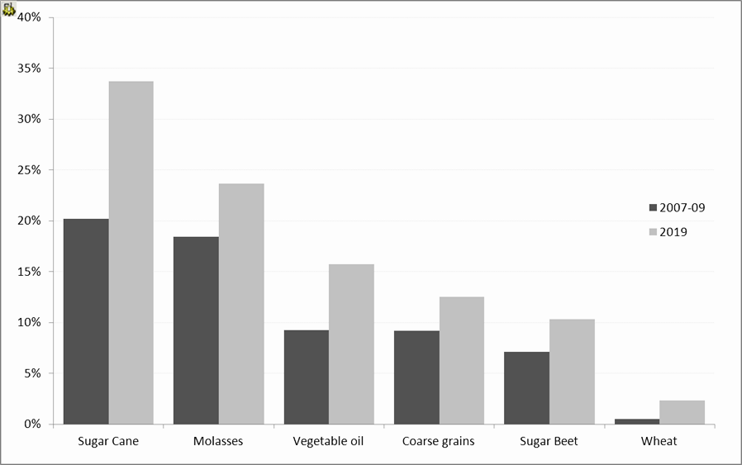

**By 2019, about 13% of the global production of coarse grains will be used to produce ethanol compared to 9% over the base.**

16% of the global production of vegetable oil will be used to produce biodiesel compared to 9% over the base. The share of sugarcane to be used for ethanol production at the worldwide level is expected to reach almost 35% in 2019.

*Source: OECD Secretariat*

**The authors of this business plan predict that success of the investment in Witaszyce will significantly depend on two essential, but independent of the debtors, external factors:**

* correct assessment of changes in raw material prices, ie prices of rye and maize
* support policy for agriculture and biofuel technologies in the world/OECD/ and in the EU

**Cereal markets in short-term perspective may be characterized by divergent price trends …**

**…. but all commodity markets tend to stabilize when viewed long-term**

The latest medium-term prognoses for agriculture of the OECD countries up to 2015 suggest positive development of the cereal sector in the nearest future.

Another rise in production will be associated with initial drop of prices, followed by gradual stabilization over the whole analysed period until 2020, along with steadily increasing demand, caused partly by the development of biofuel market.

**Geopolitical and economic situation**

The greatest unknown in the short-term perspective is negative influence of current geopolitical events on general economic conditions. With poor growth in Europe and Japan, the trend towards improvement in the OECD area is more and more dependent on the efficiency of economy in the US.

Another factor to note is the fact that an increasing deficit of the federal budget may inhibit and delay economic revival both in the OECD countries and in the world.

**Slow OECD economy growth delays the global economy.**

The OECD prognoses concerning agriculture illustrate how the agricultural sector is shaped by the national and world influences. On the global/world scale, macroeconomic conditions which are unfavorable in short term tend to improve with time.

The current world economy is now bogged in the after-effects of exchange market crisis, external fluctuations and low demand in Japan and the EU zone. The year 2012 will probably be described as the year of low global growth. The development of many OECD countries has not reached the level forecasted by trends. The slow short-term growth is partly attributable to uncertain geopolitical situation. Contrary to the continuing period of slow growth in the OECD countries, many developing countries are developing very well.

If the current difficulties are overcome, better achievements in the US economy should be the driving force for the OECD zone where moderate economic growth is expected. Japan is expected to suffer further decline.

Looking ahead, the prognosis for the OECD countries foresees a growth towards the end of the analyzed period, at the rate comparable to that of the 1990’s. A higher medium-term growth is also expected in many developing countries of Asia and Latin America, with an average growth rate at 4.5% annually.

Another important factor affecting the efficiency of the agricultural sector in the OECD countries will be changes in money exchange rates, determining competitiveness in trade and amount of agricultural products circulating over the borders. Lower exchange rates will also intensify competitiveness on the agricultural markets in such countries as Brazil and Argentina.

**Drops in prices of cereals and oleiferous seeds in short term perspective.**

There was a significant drop in wheat prices in the world in 2003 following an increase in its production as compared to the level it had declined to after droughts in North America and Australia. Later the prices were increasing very gradually, together with an increase in production and restoration of reserves, especially in the exporting countries. Generally, the global real cereal prices have for a long time had a decreasing tendency, with periodic fluctuations resulting mainly from shortage of grain with the most important grain producers or suppliers.

A sudden rise in price is usually followed by a return to lower prices due to increased production; such price trend reflects improvement of efficiency and higher crops. For the period 2009 – 2015, cereal output is expected to rise, with greater – by 15%, production of wheat and raw grain.

In the OECD zone, the policy of backing and protection adopted by the USA, European countries and Japan may have, considering the size of these countries as main producers of agricultural products and/or exporters and importers, a significant influence on medium-term analysis of the agricultural markets.

**Estimated effect of the global prices is relatively small.**

The effect on average global prices of cereals and oleiferous seeds in forecasted market conditions is relatively small, being -1% for raw grain and +1% for oleiferous seeds as compared to the forecasted world price levels, provided the FAIR Bill regulations are observed. The extent of the influence depends largely on the structure of analyses of the world prices, where lower world prices indicate greater impact in case of grain, and lower prices – smaller impact on oleiferous seeds.

**The reform of the EU policy shifts towards market orientation.**

In the last decade the EU agricultural reforms have introduced changes in the support of some sectors with a view to reduce distortions in the market mechanism. High prices advancing cereal and oleiferous seeds producers have been lowered, and direct subsidies to compensate farmers for price reductions and obligatory reserves have been granted. Also customs restrictions have been generally eased to allow better access to markets, however lately new import limits (TRQ) restricting access to the markets of some cereals have again been introduced.

**Some important sectors are still isolated from signals from the global markets.**

Many reforms aim have market orientation but producers from some main sectors are still isolated from signals from the world markets and continue to receive extensive backing. In the result, the backing for the EU agricultural sector remains on one of the highest levels in the OECD countries. Considering this, the proposals of the European Commission concerning long-term reform perspectives for balanced agriculture, published in January 2010, are an opportunity to further reduce distortions in production and trade .

**Support policy in the OECD countries**.

Concerning the kinds of support policy, several OECD countries have changed the principles of granting subsidies to producers to make them more clear-cut. However still predominant is the support for market prices, which most corrupts production and trade and is less efficient in the field of transfer of the proceeds to producers, with the greatest share allocated to a small group of chief producers. The latest approximate support prices, according to the PSE methodology (producer support estimate) show only a slight change in recent years.

Moreover, in case of some countries and some produce, the flow of prices from the world markets is low due to customs restrictions. This results in lower accessibility to world signals which might otherwise have had effect on the composition and level of (over)production, and which discriminates consumers of agricultural products. Such situation also has influence on decreases of world prices and usually exacerbates price instability.

**IV. Analysis of production costs.**

Table 1 below presents an exemplary calculation of the average production cost in % of 1000 litres of spirit, made on the following assumptions:

* optimized heat consumption at 13.5 GJ/m3 of spirit,
* continuous operation of the distillery, three shifts 350 days a year
* energy price based on the price of coal as the most commonly used fuel.

Table 1. Production viability assuming prices of 2010

|  |  |
| --- | --- |
| **Production component** | Share in % |
| **Grain** (in tonnes – averaged prices of rye and maize) | 62.27% |
| **Heat** - steam - coal (in GJ) | 17.26% |
| **Electricity** (in kWh) | 1.99% |
| **Water** (in m3) | 2.20% |
| Energy for stillage drying (in GJ) | 6.90% |
| Additional materials (in PLN) | 5.25% |
| **Labour** (in PLN) | 4.12% |
| **Total production** | **100%** |

As presented, the raw materials are the largest part of the production costs, followed by heating (steam) costs. Although the grain prices change according to market conditions, they are usually lowest during the harvest season and it is in the interest of the producer to accumulate appropriate stock during this period.

The table above presents consumption of raw material for ethanol production in the traditional azeotropic distillation technology.

**The planned alcohol production plant, however, will operate on the basis of a modern Katzen technology, using molecular sieves which results in lower consumption of raw material to produce 1 lter of ethanol:**

* 2.62 kg of rye for 1 litre of ethanol,

and

* 2.49 kg of maize for 1 litre of ethanol.

The production costs of final products are clearly illustrated in the annexes concerning the financial forecasts.

**The cost of energy needed for production of alcohol depends on:**

* optimized heat management in the production process (cold scuffing, heat recuperation),
* boiler combustion efficiency (85-90% for modern boilers),
* type of fuel used (Table 2).

In our case, the production relies on our own utilities.

Table 2. Comparison of prices and properties of possible fuels.

|  |  |  |  |  |  |  |
| --- | --- | --- | --- | --- | --- | --- |
|  | Culm (12% humidity) | Natural gas | Light oil (Ekoterm) | Medium heavy oil | Wood chips (40% humidity) | Rye straw (15% humidity) |
| **Calorific value (GJ/tonne)** | 25 | 48 | 43.4 | 40.2 | 10.4 | 14.4 |
| **Price (PLN/tonne)** | 335 | 1100 | 1200 | 820 | 120 | 160 |
| **Combustion efficiency** | 60% | 90% | 90% | 90% | 85% | 85% |
| **Price (PLN/GJ)** | 22.33 | 25.46 | 30.72 | 22.66 | 13.57 | 13.07 |
| **Quantity (tonnes per m3 of spirit)** | 0.83 | 0.45 | 0.5 | 0.54 | 2.08 | 1.50 |
| Source: Own study (2012 prices). | | | | | | |
|  | | | | | | |

Thus the use of modern highly efficient natural gas boilers (i.e. the ones that are offered by Loos International – the world leader in production of steam and water boilers) will allow to keep the heating costs at the level of coal boilers, meeting the requirements of environmental protection at the same time.

**Reduction of the production costs achieved primarily by optimization of energy consumption is the original idea of the authors of this project.**

**Investor has decided to construct the biogas plant which will work on the waste coming from ethanol production. The electrical and thermal energy produced from gas delivered by biogas plant will cover full ethanol plant demand for electrical and thermal energy, hence there will be no need to purchase the a.m. media from outside. Consequently the two plants jointly (i.e. biogas plant and ethanol plant), due to internal energy production which fully covers internal consumption will generate multi million benefits. These benefits are included in the attachments/calculation sheets to the financial model.**

## V. Analysis of legal and fiscal regulations regardIng bioethanol.

**Apart from the purchase price of raw material, the second most important element of the final price of liquid fuels from renewable sources is the excise duty.**

* 1. **Current legal regulations require** that liquid fuels from renewable sources in the EU should be charged excise duty not less than 50% of the excise duty of crude oil-based fuels.
  2. **The production cost of biofuels** is largely determined by the price of raw material "logistics" and the system of subsidies and tax preferences in all "spheres" of obtaining raw material, processing and distribution of the final product (both in the EU and U.S.).

**Current legal Act**

The European Commission raised no objections to the scheme of operating aid in the field of biofuels. Authorisation for State aid to producers in the form of bio-tax reduction was published in the EU's official journal (Official Journal EU C 247 from 15 of October 2009), remaining valid until 31 of April 2011. In accordance with article 19a of the CIT Act (Official Journal PL No. 54 of 14 June 2000, pos. 654 with amendments**) taxpayer who has obtained a permit to operate an excise registered depot, and which produces biocomponents using the raw materials from their own production or acquired, including import and intra-community acquisition, can benefit from tax allowance** **for the years 2007-2014.** Allowance is deducted from the tax in the amount equal to 19% of the excess of the biofuel manufacturing costs over the cost of producing liquid fuels with the same calorific value. This value, however, cannot be higher than 19% of the excess of the value of produced biocomponents over the value of produced liquid fuels, calculated according to average prices of biofuels and liquid fuels with the same calorific value. If the taxpayer does not produce liquid fuels, the average market price of these fuels is used to calculate the excess.

* 1. **The main directions of the alternative fuel market development** were included in the EU Directive 92/81/EEC of November 2001, and assume that the prospective replacement of traditional fuels with biofuels is estimated at about 8%, allowing involvement and use in this sphere of production of about 10% of the total EU agricultural area.
  2. **Mandatory blending of biofuels.**

The second directive concerns the obligation to blend biofuels with gasoline and diesel.

**This obligation would be introduced in several stages:**

* from 2010 the Member States will have to allocate 5.75% of their markets for biofuels in a pure or blended form, or derivative products (ETBE). This is a general solution which will require Member States to use a certain amount of biofuel.
* then biofuel share should increase by 0.75% per year until 2020, when it reaches 20%, and 15% in Poland.

|  |  |  |  |
| --- | --- | --- | --- |
| **Year** | **2005** | **2010** | **2020** |
| Biofuels share [%] | 2 | 5.75 | 20 |

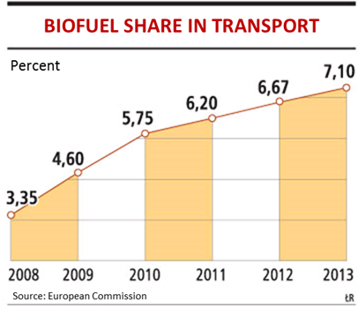

**The experts point out that without the development of the biofuel market in Poland it will be difficult for us to meet the obligation to use 20% of biofuels by 2020.**

**CONCLUSIONS:**

* 1. **There are legal regulations in the EU allowing and requiring a systematic increase in bioethanol production.**
  2. **Our investment fully meets these expectations.**

# Assumptions concerning the investment

## Location of the investmEnt – justification.

Witaszyce near Jarocin was selected as the location of a dehydrated and rectified alcohol manufacturing plant. In 1997 the Investor acquired a 49 200 m2 parcel of land adjacent to the Sugar Factory and Refinery “Witaszyce” Joint Stock Company. The choice of location was dictated by several aspects:

1. The existing Sugar Factory is equipped with own water intake and own sewage treatment system. The parcel also has a natural gas connection. The location decision takes into account primarily the existing utilities (steam, gas, water, electricity, sewage), which secure the requirements of the alcohol production plant in 100%. The estimated value of the parcel amounts to 12 million PLN,
2. The Investor has secured the right to use the existing railway siding and train weight, on the basis of a long-term lease agreement. "Aspen" Company received by decision of the District Inspector of Railways in Poznan, authorization for "reconstruction of the tracks and railway siding by the Sugar Factory and Refinery at the Witaszyce train station". This allowed the Company to repair the railway siding and to adapt it to the needs of the future alcohol plant.
3. Within the 60-80 km radius of the location of future alcohol plant, there is a possibility of buying more than 500 thousand tonnes of rye and 500 thousand tonnes of maize. This favourable location of cereal producers around the proposed alcohol plant will have a considerable impact on supply costs and, ultimately, on the costs of producing the final product.
4. The city of Jarocin, the headquarters of the Company, is located by the:
   * main car routes: Szczecin - Gorzów Wlkp. - Poznań - Jarocin - Katowice – Kraków and Szczecin - Gorzów Wlkp. - Poznań - Jarocin - Kalisz - Łódź, as well as to Lublin and Przemyśl; moreover, the route from Wałbrzych to Gdańsk passes through Jarocin,
   * significant main railway line Szczecin - Poznań - Katowice – Przemyśl; Jarocin is an important railway junction with the available option of loading or transhipment of goods and shipment to the entire country.

This favourable location of the plant will translate into low costs of transport, one of the key elements of the final price of the product.

1. Purchase of the "Witaszyce" Sugar Factory – for which there is a big chance, will primarily reduce the cost of the investment (launch of the plant), due to location in the existing buildings and structures. Full infrastructure available in the Sugar Factory, including utilities, molasses storage tanks and other sugar refinery specific structures, will not only shorten the investment process and reduce its cost, but will also enable to launch production of alcohol as early as autumn 2015.

## Technical description of the investmenT.

### Production plant infrastructure.

The planned alcohol production plant will be located in the “Witaszyce” Sugar Factory and the adjacent area (approximately 4.92 hectares) owned by Aspen Sp. z o.o. This consists of the parcels no. 570/2, 599, 600/1 and 600/2, which are subject to a land registry no. KW 21017 kept by the District Court in Jarocin.

As already stated, the location of the plant is of key strategic importance to the project, due to the use of existing installations, railway siding, electricity and sewer system.

The company has already incurred the first expenses related to the construction of the plant, that is:

* purchase of the parcel of 4.92 ha total area,
* purchase of the R. Katzen Associates International Inc. dewatering tower design,
* preparation of the construction project of the future plant,
* reconstruction of the railway siding on the leased parcel, which enables seamless handling of the raw materials and final product within the logistic structure of the plant,
* first costs incurred to build the alcohol dehydration tower

The basic technical and technological equipment of the plant will consist of:

* railway wagon rye unloading station and road transport means,
* granary for storage of raw material, or foil sleeves to store maize corn directly from a combine without drying.

The raw materials will be supplied from the grain cleaning and grinding station to the current production points, and will subsequently be divided into production of:

* rectified spirit,
* dehydrated spirit.

The materials will then be moved to the transfer points of:

* dried stillage (feed pellets) – DDGS (Dried Distillers Grains with Soluble),
* remainders of evaporators condensate to thicken the brew,
* CO2, which will be used for food and industrial purposes.

### Production plant project assumptions.

#### Production capacity

The alcohol production plant will have the capacity to produce 125 000 000 litres of 100% alcohol per year. The production will run 340-350 days a year which is equivalent to the production of 3676 hl/24h of 100% alcohol.

It must be emphasised that Katzen Inc., on the basis of Output Guarantee being an enclosure A to the Licence Agreement concluded between Aspen and Katzen Inc., warrants the production capacity of Aspen Plant as below:

* 125,000,000 litres per year of dehydrated alcohol

incl.- 20,000,000 litres per year of rectified alcohol

The plant will produce raw alcohol (92% concentration, equivalent to 3676 hl/24h of 100% alcohol), which will be converted to:

* dehydrated alcohol at 105 000 000 litres per year,
* rectified alcohol at -(20 000 000 litres per year.

#### Raw material

The Katzen Technology of alcohol production uses maize and rye as raw materials.

The ratio of raw materials will depend on the season, harvest and stock. It is however assumed that maize will be the basic material due to its efficiency, while rye due to its properties will be the main component of the rectified spirit.

**For estimating the cost of production and sale volumes, the following proportion of both raw materials has been assumed: rye 10%, maize 90%.**

The required amount of raw material to produce 1 litre of raw alcohol is:

* 2.62 kg/l of rye

and

* 2.49 kg/l of maize.

**Assuming the proportion: 90% maize and 10% rye, daily demand for raw materials will be 2.50 kg/l of raw alcohol.**

Daily demand for raw materials amounts to:

* 96,3 tonnes of rye

and

* 823,8 tonnes of maize.

**Assuming the proportion: 90% maize and 10% rye, daily demand for raw materials will be about 950 tonnes.**

We plan:

* 340-350 days of raw materials processing.

Yearly demand for raw materials amounts to:

* 96,3 tonnes of rye x 340 days = 32.742 tonnes of rye

and

* 823.,8 tonnes of maize x 340 days = 280.092 tonnes of maize.

**Assuming the proportion: 90% maize and 10% rye, yearly demand for raw materials will be 312.834 tonnes.**

The following transport means for raw materials are planned:

* 50% railway,
* 50% trucks.

The materials will be weighed using the existing rail and road weights.

The unloading of grains will be performed at a special station located at the existing railway track and stored in 6 silos of 5.552 tonne capacity each = 33.312 tonne, which covers the demand for 36 days of full production by Aspen, which in turn guarantees the continuity of production

(*silo storage capacity may be replaced in 90% by sleeves for storage of moist corn)*

**Possibilities of raw material supply for the "ASPEN" dehydrated and rectified alcohol plant**

* 1. Contracts for supply of maize and rye with the local cereals producers are planned. In the previous years, when the Witaszyce Sugar Mill was still operating, local cereals producers – farmers, used to deliver sugar beets in the amount of around 350.000 tonnes per year.

The sugar beets were grown in the Witaszyce Sugar Mill area one the basis of long term contracts.

As the Sugar Mill is no longer in operation, the land (clasified as wheat and beat soil) used before for growing sugar beets will now be exploited to grow wheat or rye or maize, for the needs of the future Aspen Plant.

It is an asset that local farmers are accustomed to:

- long-term contracts,

- logistics of supply,

and therefore it will not be a problem for Aspen to continue the cooperation on similar conditions.

1. Farmers are interested in supplying cereals for energy needs.
2. A regulation of the Polish government concerning abolition of excise duty for biocomponents of liquid fuels obtained from agricultural products produced in Poland is expected. This will make long-term contracting even more attractive to the farmers, due to greater pricing flexibility.

#### Technical data.

The technological system for grain processing will consists of:

1. grain cleaning and milling station,
2. enzymatic hydrolysis station,
3. alcohol fermentation apparatus,
4. distillation station with appliances for:
   * fermented mash distillation,
   * alcohol dehydration installation (molecular sieves),
   * alcohol rectification,
5. centrifuging of the brew,
6. devices for thickening the evaporated brew,
7. sediment gas dryers

In the production process:

* mash obtained from lower sections of the distillation columns, in the form of dry and granulated powder will be fully utilized as fodder,
* the remaining rectification residues will be recycled.

#### Technical factors and characteristics of the products.

1. Raw material.

Grains must be free of toxic elements that would inhibit alcohol fermentation. Rye/maize should contain no more than 3% of impurities prior to cleaning. Maize moisture content may be up to 15%.

1. Technical factors.
2. Steam

Saturated dry steam (dewatered and demineralised), de-oiled, free of chlorides (Cl) and NH3, NH4 compounds to protect against corrosion and ensure required quality of the alcohol, at constant pressure of 0.3 MPa at the steam distributor.

1. Cooling water

Maximum temperature of 27ºC and effective pressure of 0.4 MPa, clear, to be used in heat exchangers, free of corroding ions, chloride content max 150 ppm, free of microorganisms.

1. Production water (PW)

For the purpose of production, it must be clean, leaving no sediment in exchangers, free of contaminating mineral elements (corrosion ions), with chlorides content to 150 ppm, free of microorganisms.

Pressure: constant effective 0.4 Mpa

Cooling circulating water losses 6 % – 10%

1. Electricity

Low voltage: 380/220 V

Frequency : 50 Hz.

1. Air for appliances

Dry, oil-filtered with pressure of 0.7 MPa at the distribution collector.

1. Air for fermentation

Filtered, bacteria-free, pressure 0.18 MPa.

1. Chemicals required for production:

* H2SO4 : 96 % sulphuric acid,
* ammonium suplhate (20% of nitrogen),
* ammonium phosphate (20% of nitrogen and 50% of P2O5)
* NaOH ; 50% (caustic soda),
* NaCl2 : 80 % (calcium chloride 80% CaCl2),

Products allowed for production must be of technological quality, free of toxic elements which might inhibit alcohol fermentation.

1. Enzymes

* Enzyme L (liquefying), consumption based on NOVO Thermamyl 120 L enzymes,
* Enzymes S (saccharifying), consumption based on NIVO AMG 200 L enzymes.

1. Essential suplementary materials:

|  |  |  |
| --- | --- | --- |
| Material | Per day | Per year  (340 days) |
| Sulphuric acid (H2SO4 96%) | 2.38 tonne | 809.2 tonne |
| Ammonium sulphate (20% N) | 1.36 tonne | 462.4 tonne |
| Ammonium phosphate (20% N & 50% P2O5) | 0.54 tonne | 183.6 tonne |
| Caustic soda (50% NaOH) | 5.10 tonne | 1734.0 tonne |
| Calcium Chloride (CaCl2 80%) | 1.43 tonne | 486.2 tonne |
| Enzyme L (liquefying), based on NOVO Thermamyl 120 L enzymes | 0.30 tonne | 102.0 tonne |
| Enzymes S (saccharifying), based on NOVOE AMG 200 L enzymes | 0.68 tonne | 231.2 tonne |
| TOTAL | 11.79 t/24h | 4008.6 t/year |

1. Storage for chemicals and helper materials:

* tanks for sulphur acid : 2 x 50 m3
* rail cistern for CaCl2
* rail cistern for NaOH
* one-storey building: L=60 m, W=10 m, H=6 m

#### Infrastructure

* 1. A **new investment task** will be construction of a new 260 meter overpass connecting the boiler room with the Production Hall. The following installations will be placed on the overpass:
* steam pipeline,
* recycle condensate pipeline,
* technological sewage pipeline,
* fuel gas pipeline,
* medium voltage electrical cables.
  1. **Boiler Plant**.

The boiler plant from Loos International equipped with two gas-powered boilers with a total capacity of steam 60 t / h .

* 1. **Electrical equipment**.

The ethanol production and dehydration plant will be operated by electric power supplied with two 15 KV cables. The cables will terminate at a transformer station containing Medium Voltage distribution room, 3 transformers 1600 KVA each, and main Low Voltage distribution room located at main production hall. In accordance with the system adopted at the Sugar Factory, supply voltage will be 15 KV and transferred to 0.4 KV for direct supply of the plant’s equipment.

The electrical equipment located on the premises of the plant will consist of:

* driving engines of technical appliances;
* heating-ventilation engines;
* technological facilities of production lines;
* outdoors lighting of roads, squares and buildings.

All technological electricity receivers require high stability of the power supply and have thus been classified as category II of the supply reliability. The remaining receivers have been classified as category III of the supply reliability.

Power requirement for basic electrical equipment:

Main Production Line 3 542 KW

Cooling units ventilators + pumps 1 040 KW

Facility for receiving raw materials 80 KW

Air-compressor station and treatment plant 250 KW

Waste disposal and pumping station 20 KW

Drinking water and water treatment 20 KW

Chemicals storage room 20 KW

Outdoors and indoors lighting 150 KW

Other 200 KW

**Total 5 280 KW**

**Total required (power demand coefficient K = 0.8) 4 224 KW**

* 1. **Cooling water**.

Quantity of water for cooling: V = 2550 m3/h

Heat to be removed: Q = V x (tl-t2) = 2550 x (38-27) = 28.05 Gcal/h = 32.6 MW

Cooling efficiency of cooling units type GVI112S is q = 6.32 MW/unit.

|  |  |  |  |  |  |
| --- | --- | --- | --- | --- | --- |
| i = | Q | = | 32.6 | = | 5.61 unit |
| q | 6.32 |

For project purposes, 6 ventilator cooling units GVI112S are required.

Power required for 6 cooling units: N = 3 x 30 x 6 = 540 KW

Power required for water pumps for cooling units

and water circulation: N = 250 KW + 250 KW = 500 KW

Amount of evaporated water: G = 9.0 m3/h for one unit

total for 6 units: G = 6 x 9 = 54 m3/h

Construction of circulating water pump station and 6 cooling units is required.

* 1. **Gas for fodder dryers**.

The Witaszyce Sugar Factory is supplied with GZ 41.5 gas of the lower calorific value Wd = 7 032 kcal/Nm3. The demand for this gas in comparison to the one given in the calculation G = 1 558 m3, with Wd = 9,800kcal/Nm3 will be:

|  |  |  |  |
| --- | --- | --- | --- |
| G41.5 = | 9800 x 1558 | = | 2171 Nm3/h |
| 7032 |

It is necessary to build underground or surface gas pipeline to make extension from the existing reduction station to the new plant. Assumed gas pressure will be about 3 ÷ 4 bar.

* 1. **Compressed air**.

Compressed air for electronic appliances will require pressure: p = 0.7 MPa

In the central compressor room, a screw compressor of efficiency 2.5 ÷ 3.0 Nm3/min will be installed.

Power needed to drive the compressor is: N = 20 KW

The air will be dewatered, deoiled and filtered.

The compressed air supply network for appliances will be independent.

For pressure stabilization there will be surge tanks installed, of capacity about V = 4 m3.

* 1. **Waste and sewege system**.
* Industrial waste: The technology and know-how of RAPHAEL KATZEN ASSOCIATES INTERNATIONAL, INC, whose technological process licence will be bought and applied by Aspen, does not allow for any industrial waste. This fact was indeed the major factor in the choice of Katzen Inc. licence.
* The plant will employ 90 persons. Sewage from the Plant will be pumped to the Sugar Factory sewage system.
* The existing industrial waste pumping station at the Witaszyce Sugar Factory, due to necessary construction and building works related to the new plant, will have to be relocated. Consequently, a new pumping station must be erected, and waste and sewage pipelines network renovated and modernized.
  1. **Drinking water supply**.

The Plant demand for water is 113m3/h. Water will be supplied from the communal water supply system, which, if required, will be expanded to meet the Plant needs.

Water treatment for technological purposes will be defined once the chemical-physical parameters of the supplied water have been determined.

The new Plant will need to be equipped with a raw water pipeline system and a treated water pipeline system for technological purposes.

Estimated diameter of the water pipe: ∅130 ÷ 150 mm.

Material – PE water pipes.

#### Storage and distribution of the alcohol.

* 1. **Alcohol dehydrated to 99.8%.**

Daily production of alcohol dehydrated to 99.8% is: 3 182 hl/24h = 318.2 m3/24h.

Storage of dehydrated alcohol is planned in 2 tanks capacity of 2,000 m3 each (in total 4,000 m3) which equals 13 days of production.

The tanks will be made of steel, adequately protected from corrosion.

The tanks will be placed in protected tank containment area resistant to alcohol.

The containment area capacity is 1.2 of tank capacity.

Distribution:

The final product i.e. alcohol dehydrated to 99.8%, will be delivered to the customers by railway. Assuming one cistern capacity to be V = 50 m3, the number of cisterns for daily production will be I = 308.8/50 = 6.17 cistern; with railway cisterns capacity being 25 m3, the number of cisterns to collect daily production will be I = 308.8/25 = 12.35 cisterns.

A railway loading station must be constructed, with measuring and pumping facilities.

The mean hourly pumping efficiency of the station should be about 12 m3/h. To improve distribution, the efficiency of pumping station and platform operations should be aimed at 25 m3/h, which means that a 25 m3 cistern will be filled within approximately 1 hour.

For positioning of railway shuttle of 38 cisterns, the length of the siding should be about 500 ÷ 600 m.

Power required for the fuel pumping station will be N = 4 KW for pumps + 2 KW for ventilation.

* 1. **Rectified alcohol.**

Daily production of rectified alcohol is 588 hl/24h = 58.5 m3/24h

The rectified alcohol can be sold as:

* Natural alcohol (pure alcohol)
* Consumable alcohol
* Pharmaceutical alcohol

Due to the fact that the technical specifications for a.m. alcohol types (defined by the relevant Polish Standards) differ from each other, separate 560 m3 capacity tanks are planned for different type of alcohol (in total 3 tanks of a capacity of 1,680 m3). This will allow to store 9 days of production for each type of alcohol (in total 27 days).

The tanks will be made of stainless steel 1H18N9T and placed in ecological, resistant to alcohol tanks’ containment area. Its capacity will be 1.2 of buffer tank capacity.

Daily alcohol production will be collected by 2 ÷ 3 railway or car tankers (capacity of 25 m3).

## Organization of the investment process.

On the basis of long-term agreements signed with the Witaszyce Sugar Factory and Refinery and on-going negotiations concerning the purchase of assets of the Sugar Factory, the Investor may at any time commence with the investment project of the construction of the dehydrated and rectified alcohol manufacturing plant.

The investment will be based on the budget presented in Chapter 3 “Assumptions concerning the investment”, point IV. This budget may be subject to slight modifications resulting from the takeover of assets belonging to the Sugar Factory, as well as macro-economic reasons related to the implementation of the project.

1. **Construction**

The construction work will be performed with accordance to the design and will be based on a system of "general contractor". At the moment the construction company, which would act as the general contractor and supervise the construction project has not yet been selected. The essential criteria for the selection of general contractor are:

* price,
* experience and references,
* financial situation,
* proposed collateral and guarantee.

Possibility of supervision of the Investor over the choice of subcontractors will be an additional condition for selection of the general contractor.

The adopted system of contractors selection and investment realization will provide high efficiency, possibility of effective enforcement of deadlines, and – if necessary – the possibility of rapid replacement of unreliable contractor by another company.

1. **Banking Supervision Officer**

Due to planned investment financing with a loan (bank credit), it will be necessary to appoint an external company, accepted by the bank, to act as a bank supervisor of the construction works.

A final report as well as current reporting on the stage of construction work will be prepared, if required by the banks.

## Investment budget.

**The budget of the alcohol production plant investment is presented in the appendix (financial model).**

## Investment schedule.

The duration of the investment will be 30 months.

The Appendix to the Business Plan contains a detailed investment schedule, including the costs of:

1. design and supervision,
2. road works,
3. installation of utilities,
4. construction works,
5. technical appliences,
6. equipment,
7. preparation of the technological process,
8. reserves.

In each month of the investment period, the combined investment costs (without financial costs) will be incurred as per the enclosed financial model.

## Funding.

### Assumptions

We assume a combined funding from own resources and bank loans, which is a typical model for this kind of projects.

Own resources will be used to cover both the demand for long-term financing (equity) and to cover working capital needs.

The bank loan will cover the financing of both long- and short-term needs.

The long-term bank credit should cover the investment, financial costs of the investment period and the Company operating costs, i.e. all expenditures which can be classified as fixed assets in accordance with the legal regulations[2].

In addition, the short/medium term loan should provide the funding of Company’s current assets (VAT credit and credit for the purchase of raw materials needed for production).

The source of loan repayment will be:

* settlement of VAT – with respect to the short/medium term loan,
* revenues from sale of final products in the form of rectified spirit, bioethanol and feed pellets – for long-term loan and the short-term loan for the purchase of raw material.

The repayment schedule will be adjusted to the projected cash flows of the Company.

### Equity

The equity have already been fully paid up during the last few years:

* The Investor has purchased the parcels no. 570/2, 599, 600/1 and 600/2 in Witaszyce, which are subject to a land registry no. KW 21017 kept by the District Court in Jarocin, of the total area of 4.92 ha.
* The Investor has purchased the licence of R. Katzen Associates International Inc., which allows to use the Katzen technology for production of alcohol.
* The architectural and construction design of the future alcohol manufacturing plant has been prepared.
* The railway siding existing on the leased parcel has been renovated and upgraded, which will eventually assist in the transport of the produced spirit.
* First expenditures for the construction of the alcohol dehydration tower have been incurred.

### Long-term credit

The investment will be financed by a long-term bank loan

Due to the prepared schedule of the investment, it is assumed that:

1. The crediting period will consist of:
   * duration of the investment
   * grace period in the repayment of capital
   * capital repayment period

### VAT credit

According to existing VAT regulations, the construction and assembly work as well as the purchased technological line are subject to VAT at 23%. Due to the need for payment of VAT on the date of invoice and even a few months period for due VAT repayment imposed by the legislature, it is assumed that a short-term loan will be used to cover the VAT liabilities.

The loan amount was estimated on the assumption that after the commencement of direct reimbursement, the due VAT balance will be at the level of total input VAT for the last six months.

### Credit for the purchase of raw materials needed for production

The duration of the investment will be about 30 months, and therefore the production is assumed to start in September-December 2015. Due to the expenditure on the investment, the Investor will have a demand for short-term loan, which will be used entirely for the purchase of raw materials.

### Expected conditions of the credit

The assumptions regarding credit terms and conditions take into account the current bank offer of long-term loans for investments secured by mortgages. The potential of the "Aspen" Company and the size of the investment have also been taken into account.

The expected conditions of credits have been given in sections:

* C. Long-term credit,
* D. VAT credit,
* E. Credit for the purchase of raw materials needed for production.

The general assumptions are:

* + the interest rate based on the variable WIBOR rate increased by bank’s margin,
  + loan commision amounting to 0.75%.

### Collateral

The basic collateral of the loan will be:

1. mortgage on the parcel of 4.92 ha located in Witaszyce (no. KW 21017) owned by the Investor.
2. mortgage on the purchased parcels/plots (sugar plant)

An additional collateral will consist of:

* transfer of machines and appliances
* transfer of claims arising from contracts for the sale of the products,
* transfer of ownership for collateral of production in progress and final products,
* assignment of rights from the “Aspen” Company property insurance policy,
* Investor’s promissory note

**4. Financial projections of the investment**

### I. Assumptions

The forecasted financial statements for the Investment can be found in the Appendix. The basic assumptions on evolution of the financial results and simplified versions of financial statements are given below.

It should be noted that the financial projections have been prepared with a large safety margin, as the projected sales prices of the final products will probably evolve to a higher level than it has been presented in this business plan. In addition the purchase prices of raw materials are set slightly higher than the expected inflation and current prices of raw materials on the Polish market.

**Balance sheet:**

The balance sheet items are determined by the production volume, costs of production and sales volume.

**Fixed assets:**

Intangible and legal assets:

- the value of the Katzen technology license and know-how.

Land:

- the land consisting of the parcels no. 570/2, 599, 600/1 and 600/2 in Witaszyce, which are subject to a land registry no. KW 21017 kept by the District Court in Jarocin, of the total area of 4.92 ha.

Buildings and structures, technical equipment and other fixed assets:

- in accordance with the scope of investments and the purchased Sugar Factory.

Assets under construction:

- expenditures associated with the construction of the alcohol production plant, capitalized financing costs and the operating costs of the Company associated with the investment.

A systematic amortization of fixed assets, as well as replacement- only expenditures in respect of other assets and means of transport have been assumed.

**Current assets:**

Inventories:

- materials – from 2015 the stocks of materials will be maintained in the amount of 7 days.

- finished products – from 2015 the stocks of finished products will be maintained in the amount of 7 days.

Trade receivables:

- in the amount of one-month sales in line with the assumptions of future contract of sale.

Budget claims:

- VAT due:

* from the investment expenditures of the investment period,
* to be settled with the output VAT on sales.

Cash:

- included.

**Liabilities:**

**Equity:**

- contributed to the Company.

- annual increase of equity with retained profit is assumed.

**Long-term liabilities:**

- investment credit.

**Short-term liabilities:**

Credits and loans:

- VAT credit for the duration of investment,

- current account credit.

Trade payables:

- in the amount of two-week production costs.

The remaining balance sheet items were considered irrelevant and have been omitted.

**Profit and loss account:**

**Revenues from sales:**

The production is planned to commence in September-December 2015.

Production capacity:

1. in 2015 will amount to 10-40% of projected capacity, i.e. the plant will produce:
   * dehydrated spirit
   * rectified spirit
   * fodder ingredient
2. in 2016 the production capacity will reach 90%,
3. from 2017 the plant capacity will reach 100%, so the production of individual products will reach:
   * dehydrated spirit – 105 million litres,
   * rectified spirit – 20 million litres,
   * DDGS fodder ingredient – 115,500 tonnes.

This financial projection has been prepared on the basis of the following minimum selling prices:

* + dehydrated spirit – sale price – 3.00 Zł/l
  + rectified spirit – 3.10 Zł/l
  + DDGS fodder ingredient – 1,000.00 tonne

The financial projections made no assumptions about the indexation related to inflation changes.

The Investor is already incurring operational costs of the Company resulting from the depreciation of the land and associated fees as well as additional costs associated with maintaining the Company.

Depreciation:

- calculated on the basis of current and predicted structure of assets. Individual assets will be included in the structure of the balance sheet after the completion of the investment. Moreover, the asset structure has been verified for settlements related to exemption from the property tax.

Materials and energy:

- in accordance with the Accounting Act, in case of manufacturing companies this item includes consumption of raw materials as well as energy, water, packaging and others.

External services:

- transportation services. It was assumed that the transport of raw materials and sold products will be performed by cars and rail.

Taxes and fees:

- other fees.

Salaries and social benefits:

- estimated according to the data contained in Appendix.

Other costs:

- contingency provision for unforeseen expenditures.

**Financial costs:**

- related to the financing of investment, VAT and the cost of purchasing of raw materials.

- have been discussed in Chapter 4.I ‘Assumptions’

**Income tax:**

- currently applicable 19% corporate tax rate has been assumed,

- no settlement of losses of the investment period has been assumed.

The following items were considered irrelevant and have been omitted in the projection:

- other operating income and expenses,

- financial revenues, although in the case of maintaining the assumed cash balances, the deposit interest would significantly affect the financial results of the Company.

**Cash flow statement:**

The cash flow statement has been prepared on the basis of changes in the balance sheet and the profit and loss account.

A complete financial model presenting the Aspen Company financial results in the periods listed below, can be found in the appendix to this business plan:

* + 1. before the investment – the years 2012 – 2013,
    2. during the investment – between September 2013 and September-December 2015 – the financial projections are presented in a monthly breakdown.
    3. production launch and grace period – from September-December 2015 ,
    4. repayment of capital – six year repayment period has been assumed

## II. Analysis of profitability of the investment project

The financial model attached to the business plan includes the projections of the financial statements, together with sensitivity analysis.

# 5. Management and structure of employment

The schedule of investment assumes a gradual increase in employment from 2014 , starting with trainings run by the supplier of technology followed by hiring staff of various levels skilled to commence production.

The structure of employment and expected reimbursement costs excluding ZUS (Social Insurance) or insurances will be as follows:

|  |  |  |
| --- | --- | --- |
| **No.** | **Position** | **Number of posts** |
| 1. | Board | 2 |
| 2. | Technological department | 2 |
| 3. | Production department | 60 |
| 4. | Maintenance department | 6 |
| 5. | Laboratory | 4 |
| 6. | Supply and sale department | 4 |
| 7. | Storage department | 4 |
| 8. | Human resources department | 2 |
| 9. | Health and safety | 1 |
| 10. | Accounting department | 4 |
| 11. | IT | 1 |
| **TOTAL** | | **90** |

Organizational chart of the plant



# 

The management during the construction of Aspen plan and during an exploitation will base on very experienced specialists. C/Vs of the candidates are presented below.

1. CURRICULUM VITAE

Name: **PIOTR LASKOWSKI**

Tel: Mob, Res: + 48 502 284 271, + 48 42 616 8545

E-mail: laskowski.piotr@onet.pl

Date of birth: 4th April 1950

Nationality: Polish

# Education

* 1. Grammar School
  2. Technical University of Lodz (Poland), Faculty of Civil Engineering
  3. University of Lodz, Faculty of Economy

# Academic Qualifications

1. M. Sc. in Civil Engineering
2. M. in Management in Engineering Industry
3. Qualified Chartered Engineer
4. Academic qualifications approved by the Institution of Civil Engineers in the UK

## Professional Experience

**Self Employed**

2011-till now Site Manager for Construction of LNG Terminal Project in Swinoujscie (total value of construction works – 700 mil. Euro)

2009-2011 Consultant for installation of steel structure and roof over National Stadium in Warsaw

**Employer:** PPS Pipeline System GmbH

Hindemburg Strasse 36, D-49610 Quakenbruck, Germany

2006-2009 **Position:**

Project Manager for responsible for projects in the field of infrastructure and energy executed by PPS in Romania:

(i) Water Rehabilitation Project in Romania

(ii) Construction & Installation of Gas Compressors Project in Romania

**Scope of Works:**

* 1. Water network, water treatment plants, pumping stations, chlorination plants, water reservoirs.
  2. Civil works, Compressors’ installations, mechanical & piping works, electrical, control systems, SCADA.
  3. **Position:**

(i) PPS Lithuania Branch Manager.

(ii) Project Manager for “State Ignalina Nuclear Power Plant (INPP) Projects” in Lithuania

**Scope of Works:**

(i) General supervision and coordination over projects executed by PPS

(ii) Internal Installations inside INPP: Heating system, water supply system, rehabilitation of technological pipelines.

2001-2003 **Position:**

Branch Manager for PPS subsidiary in Poland

**Scope of Works:**

Managing PPS activities in Poland (gas pipelines)

1996-2001 **Employer:** Preussag Wasser & Rohrtechnik GmbH

Karl Wiechert Allee 4, D-30625 Hannover, Germany

since 1999 due to change of company ownership:

PPS Pipeline System GmbH, D-49610 Quakenbruck

**Position:**

Project Manager for Butinge Oil Terminal Project in Lithuania

**Scope of works:**

Oil Terminal at Butinge, oil export capacity - 8 million tonnes/year, oil import capacity - 5 million tonnes/year;

Oil storage tanks of total capacity of 150,000 m3 plus auxiliary tanks;

Onshore pipeline – 100 kilometres

Offshore pipeline – 7.5 kilometres plus oil loading/unloading buoy

1993-1996 **Employer:** Josef Riepl Bau AG

Meglingerstrasse 19, D-81477 Munich, Germany

**Position:**

Project Manager for Wovwe Hydropower Scheme in Malawi

**Scope of works:**

Power house, penstock steel pipeline, tunnel, dam, water intake

1992-1993 **Position:**

Project Manager for Dam and Water Treatment Plant in Kasungu, Malawi

**Scope of works:**

Earth dam, concrete spillway, water treatment plant, chlorination plant, water reservoirs, water supply and distribution pipelines

* 1. **Position:**

Branch Manager of Zambia Branch in Lusaka

**Scope of works:**

Supervision over Company Projects (roads, bridges, water pipelines, industrial buildings, etc.) and Company activities in Zambia

1990-1991 **Position:**

Project Manager for Sewage System Project in Serowe, Botswana

**Scope of works:**

Sewage pipelines, sewage treatment plant, settlement tanks,

1989-1990 **Employer:**  Wade Adams Construction Company

3 Shortlands, London W6 8AL

**Position:**

Project Manager for Fuel Facilities Project in Mbeya, Tanzania

**Scope of works:**

Earth & concrete works, fuel tanks, pump station, railway siding, roads.

1982-1989 **Employer:**  Budimex Company

**Position:**

Project Manager for various projects (mostly land reclamation projects) in Iraq

1973-1982 Site Engineer and Project Manager for various construction projects in Poland

**References**

* + various reference letters from the Employers, Consultants and Investors: PPS Pipeline Systems GmbH, Eptisa Internationales SA - Romania, SNGN Romgaz SA - Romania, Butinge Oil Terminal - Lithuania, Ministry of Agriculture and Irrigation – Iraq, others

references available on request by telephone, email:

* + Mr. Alan Rhead – UK, tel office: +44 1926491333, tel mob: +44 7764362400 ([www.abrhead.com](http://www.abrhead.com)), the Director of AB Rhead Co. that provided contract administration services for Butinge Oil Terminal Project and Ingalina Nuclear Power Plant Project.
  + Mr. Erich Niedermyer – Germany, tel res: +49 80615616; tel mob: +49 1713086335; email: E.Niecons@t-online.de, the Director of Josef Riepl Co. (at present retired), my direct supervisor from the Company Headquarters in Germany during my work as a Project Manager in Africa in 1990-1996.
  + Mr. Dietrich Keck – Germany, tel: + 49 5431 92203; tel mob: + 49 171 61117536; email: dietrichkeck@t-online.de, the Director of PPS Pipeline Systems GmbH (at present retired), my superior during my work as a Project Manager for Butinge Oil Terminal Project in Lithuania.

**2.**

|  |  |  |  |
| --- | --- | --- | --- |
| fotka | | DARIUSZ LISTKIEWICZ  ul. Sikorskiego 31/13  62-031 Luboń | tel. +48 61 899 51 07  mobile +48 606 747 909  e-mail listkiewicz_xl@wp.pl |
| professional experience | since 01.2005 InEkos Sp.z o.o. Poznań  Vice-President of the Board   * Negotiations with customers and preparing contracts * Preparing technical documentations | | | |
|  | since 03.2002 My own business activity Luboń k/Poznania  Technical and management advisor, cooperation with firms:  Biuro Inżynierskie “KONSULTANT” Poznań   * Technological projects and advises in food industry, e.g. making complete project, supervising process of construction and starting up of technological degumming line for crude rapeseed oil in Malczewo (Petroestry Sp. z o.o.)   Ryszard Wieczorek Poznań   * Making documentation and initiation of management systems, e.g. Integrated Management System compatible with ISO 9000, ISO 14000, OHSAS 18000 and HACCP in Sieraków (BARTEK Meat Plant) | | | |
|  | 05.1999-02.2002  Wielkopolskie Przedsiębiorstwo Przemysłu Ziemniaczanego S.A. (WPPZ S.A.)  (Potato Processing Plant) Luboń k/Poznania  Assistant Manager of Production Plant in Luboń   * Supervising over 100 workers * Organization of production activity in plant * Supervising of production supplying and process control * Managing affairs connected with environmental protection * Being in contact with external institutions and firms connected with sphere of activity * Supervising of preparing and realizing budgets in submitted departments * Working out plans of modernizations and investments | | | |
|  | 02.1997-04.1999 P.W.Ekos Sp.z o.o. Poznań  Environmental Protection Specialist   * Negotiations with customers and preparing contracts * Preparing technical documentations | | | |
|  | 07.1993-01.1997 WPPZ S.A. Luboń k/Poznania  Chief of Basic Production   * Supervising and organization of three production departments * Managing affairs connected with environmental protection * Being in contact with external institutions and firms connected with sphere of activity | | | |
|  | 10.1985-06.1993 WPPZ S.A. Luboń k/Poznania  Chief of Water Treatment Department   * Supervising and organization of subsidiary department * Managing affairs connected with environmental protection | | | |
|  | 06.1982-09.1985 Cement Plant „Chełm” Chełm  shift foreman   * Organization of shift in electric department | | | |
| Supervision experience | 05.2000-02.2002 PPZ S.A. Niechlów  Member of Supervisory Board   * Supervising company | | | |
|  | 1993-1995 Perkom Sp. z o.o. Luboń k/Poznania  Member of Supervisory Board   * Supervising company | | | |
|  | 1992-1993 WPPZ S.A. Luboń k/Poznania  Member of Supervisory Board   * Supervising company | | | |
|  | 1994-1998 Municipal Government Luboń k/Poznania  Member of Municipal Government (supernumerary)   * Supervising of town activity in environmental protection * Representing town in affairs connected with environmental protection sphere * Supervising of Town Environmental Protection Fund and gain money from other funds | | | |
| Education | 1977–1982 Academy of Mining and Metalurgy Kraków   * Education in Electrotechnics, Automatization and Electronics Faculty, specialization - automatization and electrification of mines * Graduate with M.Sc. degree | | | |
| Courses | 02-03.1995 Business School of Wielkopolska Poznań   * Cours for candidates for Member of Supervisory Board in Public Purse companies * Passed an examination before Examining Board under the care of Minister of Proprietary Transformations   03.1989 Work Safety Society Poznań   * Work safety course for technical supervisors | | | |
| Others | 2000-2002 Agriculture Academy Poznań   * Participation in The Fifth FRAMEWORK Programme Commission of the European Communities (waste water treatment with use of thermophilic bacteria)   1994-2000 Polziem Sp. z o.o. Poznań   * Lecturing in courses for starch industry workers * Participation in Government Examining Board for starch production foremans   Languages:   * English * Russian   Many years’ contacts with foreign firm, most with Westfalia Separator AG (now in GEA group), taking part in starting up technological lines – potato protein production and potato starch extraction / refining | | | |

**3.**

**CHRONOLOGICAL RESUME**

**Mirosław Klecz**

47 Długa Street

Luboń 62-031

Wielkopolska

Email: kon2006@o2.pl

Mobile: 505794050

**Key skills**

- Highly creative individual.

- Works effectively independently and equally as part of a team.

- Good communication and interpersonal skills.

- Gained a high standard of technical skills.

- Ability to work within a tight budget and limited timescale.

- Keen to learn new skills.

**Education**

October 1979 - May 1984

Poznan University of Technology

MSc of science in mechanic

**Work Experience**

February 2009 - June 2010

Managing director at POLGAR (trading company - pumps) in Chyby

- Responsible for maintaining contacts with clients.

- Performed a variety of duties.

- Managed a small team of co-workers.

February 2002 - June 2010

Self-employment at own bussines in Luboń

- bio-fuel production plant – designer.

- Managed a small team of co-workers.

1989 - 2002

Production manager at WPPZ Lubon SA (Potatos processing company) in Lubon

- Worked as part of a team.

- Responsible for production.

- Creating reports.

- Responsible for training the new employees.

- Performed a variety of duties.

**Computer skills:** Microsoft Access, Excel, Word, CAD

**Language skills:** Russian – good, English – intermediate, German – elementary

**Memberships:**

MALTEX joint stock company President of the Board 1996 – 1998;

MALTEX joint stock company President 1998 – 1999;

Supervisory Board Member „ZETPEZET” Pila 1997 – 2002

Association of Scientific, Technical Engineers and Technicians in the Food Industry member

**Interest:** Nordic-walking, photography, cycling, books.

# 6. Marketing analysis and plan of the ASPEN company

### Characteristics of the industry in the eu

1. Increased interest in the opportunities of bioethanol production in Germany is clearly observed.
2. This is consistent with previous postulates of experts from the European Commission in Brussels recommending the implementation of EU directives on that matter.
3. EU Member States including Germany should develop plans for introduction of biofuels into retail.
4. In order to popularize the use of biofuels, the European Commission recommended introduction of tax credits for biofuels by the member countries.
5. According to the experts, without tax incentives which would be reflected in the retail prices, it would be difficult to expect the drivers throughout the EU to use biofuels, which include ethanol.
6. Therefore, a number of EU countries have already prepared plans for the permanent inclusion of biofuel tax credits. Thus, for example tax relief granted recently by the Ministry of Finance of Finland for this type of fuel is 0.30 euros per litre.
7. Technical capacity for the use of bioethanol as a fuel varies, ranging from its use as a pure fuel to various types of blends of bioethanol with gasoline.

**The biofuel market in Germany:**

1. The experts currently evaluating gasoline market in Germany at around 57 million tonnes, consider the market share of bioethanol in the amount of about 3 million tonnes to be feasible.
2. In their view, bioethanol will have a principal share in the renewable energy. Manufacturers of the fuels take into account the fact that the gasoline previously used in road transport complies with the DIN standard, which in the initial stage made it possible to only gradually raise the quantity of biocomponent additives in gasoline to 5.75%.
3. According to experts, after 2010 this share will further increase to up to 15%.
4. It is estimated that currently in Germany there are installations for production of bioethanol in various phases of planning work, with total capacity of 1.65 million tonnes.
5. 0.38 million tonnes of this total is supplied by the companies Südzucker and Nordzucker. 1.27 million is supplied by a consortium of producers, which is seeking more investors in the capital market and plans to build bioethanol production plant in Mecklenburg - Western Pomerania.

**An important condition that can support more rapid implementation of the bioethanol production development plans in Germany is the considered possibility to introduce appropriate regulations limiting import of bioethanol. This applies especially to the import from Brazil, which is very attractive mainly due to low production costs and relatively weak currency.**

## II. Allowances and incentives policy

1. **Production and use of liquid biofuels, including bioethanol,**

has become a subject of major legislative initiatives in the EU Member States and the European Commission in recent years. In recent months it has also became a major subject of political debate in Poland. There is a growing belief that biofuels are a good solution for Poland and especially for domestic agriculture. The debate has brought about a systematic increase of awareness in this regard, generating more and more proposals for financial and legal mechanisms to support the development of domestic biofuel production.

1. **When it comes to the best of biofuels - bioethanol**

- alcohol produced from starchy materials, mainly wheat, potatoes or molasses - the production is already functioning in Poland. There is also a system of incentives for mixing this fuel with gasoline – every year the Minister of Finance specifies the amount of tax relief for gasoline which contains 4.5-5% of dehydrated alcohol.

*Why is it so?*

Ethyl alcohol has been a very good admixture to leaded fuels. In other countries, including EU, and soon in Poland, ethanol is not only exempt to excise duty but various other reliefs apply in case of mixing it with gasoline and mineral oil. As a result, the production of bioethanol in EU countries is growing fast, as the incentives make its price competitive to conventional fuels.

**The same developments in the fuel market can be expected in Poland.**

**1.) New proposals for reductions in the excise duty on biofuels**

Biofuel market development is to be facilitated by reliefs in excise duty. Poland has to adjust its law with regard to biocomponents to the EU regulations in the near future.

**2.) The Ministry of Finance has already introduced**

lower excise duty for each litre of added biocomponents.

**3.) The Ministry of Agriculture has appointed**

the Commission for the Biocomponents used in liquid fuels and liquid biofuels.

**4.) Therefore production of raw materials for biofuels**

is a great opportunity for Poland, according to the governments and parliaments of both Poland and EU.

**5.) Poland may be an exporter of raw materials for biofuel production**

or become an exporter of biocomponents.

**CONCLUSIONS:**

**1.) If Poland is to take advantage of the added value**

on processing of agricultural raw materials - rye, potatoes, maize, sugar beets - the components for biofuels, Polish investors who want to produce biocomponents need support. The most economically efficient solution is to use these raw materials for production of bioethanol in Poland.

**2.) This is however an expensive installation**

computerized, to allow to obtain a product corresponding to the standards of the World Fuel Charter.

**3.) Therefore we as a Polish Company would like**

to start production as early as 2015, to be able to produce in Poland as much organic bioethanol as possible.

## III. Analysis of prices and profits from the sale of biofuels.

**1.) Market price of 1 litre of bioethanol**

is inseparably linked to the price of crude oil and gasoline, which are still peaking, while the production cost of biofuels is stabilizing at an optimistic predictable level (about 60% of production costs).

**2.) Hence we can say confidently,**

that the problems of low price or no profit from bioethanol do not exist – its production is everywhere always profitable.

**3.) For the next few years**

one can safely assume that every zloty (PLN) invested in biofuels will immediately return two.

**The price of 1 litre of bioethanol is decidedly lower than the price of gasoline.**

**This is the simplest answer, and the price formula for the future.**

**CONCLUSIONS:**

1. **According to the Ministry of Agriculture considerable national and foreign capital**

is interested in production of bioethanol in Poland for industrial purposes.

1. **Bioethanol produced this way**

could be exported to other EU countries such as Germany or Sweden, where the consumption of biofuels has doubled over two years.

1. **It is therefore safe to say**

that every produced litre of bioethanol will immediately find a buyer, both in Poland and in the EU.

1. **The same applies**

to practically every quantity of biofuels, which is possible to obtain using Polish crops.

1. **Our company – ASPEN**

**-** would like to meet this challenge with the help of **Your Bank**.

## IV. ANALYSIS OF Competition

In terms of quality Polish spirits are not inferior to spirits produced in the European Union.

In Poland, the rectified spirit is divided into three categories: de luxe, select and common; in the EU there is no such classification.

The increase in use of biofuels is not only due to environmental and agricultural reasons, but also due to energy security of various countries.

**Global/world production of bioethanol was:**

20 bln litres in 1985,

25 bln litres in 1990,

40 bln litres in 2005.

1.) Production of agricultural distillate (spirit) in Poland is currently performed by fermentation in agricultural distilleries.

2.) In accordance with the appropriate EU Directive, Polish accession to the EU is associated with an increase of the share of renewable energy in the country's energy balance, and thus the implementation of the biofuel program. In the coming years this will generate a significant increase in demand for spirit, which after dehydration (ethanol) will be used as fuel admixture.



3.) New opportunities for agricultural distilleries and their cooperating farms will therefore appear, on the condition that these distilleries will be able to meet the price competition in the free EU market.

4.) In addition, agricultural distillery, like any other food industry manufacturing plant, is subject to environmental protection requirements in terms of:

- gas emissions,

- water usage and sewage,

- recycling and waste management.

European and American distilleries acting in the free market conditions optimized their production costs by making necessary modernizations of the manufacturing processes a long time ago.

In these modernized distilleries the energy consumption has considerably decreased to 13.5 GJ/m3 of spirit, which significantly reduced the final cost of production and reduced the negative impact of the distillery on the surrounding environment.

**OUR INVESTMENT PROJECT PLANS TO ADOPT SUCH SOLUTIONS.**

5.) Competition

A large share of the Polish production of bioethanol comes from the main producer – Akawit

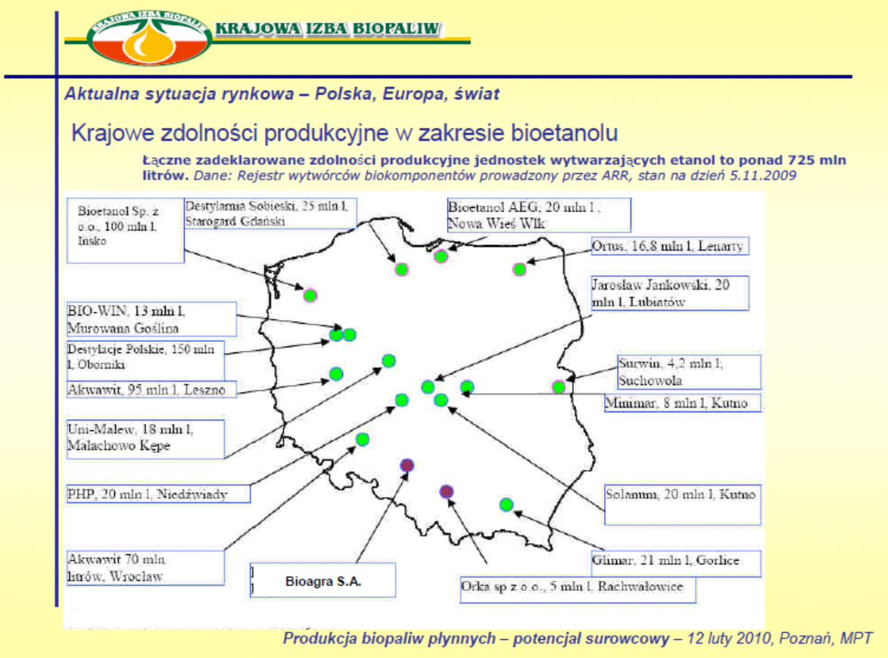

**- the Akawit company uses two technological lines:** for production of spirit for consumption (made in France) and for production of dehydrated spirit (made in USA).

**6.) Other producers,**

- The company **Wielkopolskie Biopaliwa** has demonstrated some progress,

- The company **Kuchcik** from **Jasło** has also announced considerable investments.

**The Polish biofuel industry therefore has no chance to quickly meet the EU requirements taking into account current production capacity of domestic producers.**

**CONCLUSION:**

In this situation, each new producer will be very welcome.

7. SWOT analysis of the Investment

**Strengths:**

* continually growing demand for biofuels, resulting not only from the ecological disturbances and climatic cataclysms but also from depleting fossil fuel resources,
* most vehicles can use fuels with addition of 15% of bioethanol without any modifications to the engine,
* bioethanol added to petrol increases the fuel octane number and decreases emissions of carbon monoxide,
* preferential fiscal policy for biofuel production (excise tax relief, subsidies to farmers),
* modern production technology, due to which the use of raw materials for production is lower than in the traditional azeotropic technology,
* very good location of the production plant - in the radius of 60-80 km there are cereal growing farms which can offer for sale a minimum 500 thousand tons of rye and 500 thousand tons of maize, on the basis of long-term contracts,
* high production profitability which results among other things from:
  + the use of very good and modern technology from Katzen,
  + low operating costs - the cost of the raw material constitutes on average approximately half of the price of the final product,
  + low transport costs, due to very good location of the plant from the point of view of export, including nearby main railway line (Szczecin-Poznań-Katowice-Przemyśl).
* current market price of bioethanol is competitive in relation to previous fuel prices,
* no risk in the repayment of credit liabilities due to high IRR indicator and high profitability of bioethanol production and also high indicator of liabilities return.

**Weaknesses:**

None.

**Opportunities**

* + 1. Realization of the European Directive up to 2020 - 20% of renewable energy
    2. Realization of the European Directive – 15% of renewable energy in transport up to 2020 (only in transport Poland is allowed to decrease it to 15%)

**Threats:**

* risk connected with the growth of competition in the short-term may translate into decrease of prices ,
* currency exchange rate risk – the Investor is negotiating with a foreign partner and if the contract is signed, it may be subject to the risk of exchange rate fluctuations (EUR/PLN and USD/PLN), affecting the financial results,
* interest rate risk – the Investor will be using loans, consequently the rates of interest are of essential bearing on the level of financial costs,
* the risk of instability of the tax system in Poland.

1. Polish Statistical Office
2. Accounting Act of 29 September 1994, Art. 28 Par. 8: The purchase price and the cost of fixed assets under construction, fixed assets and intangible assets includes their total costs incurred by the entity for the period of construction, installation, adjustment and improvement to the balance sheet date or acceptance for use, including:

   non-deductible tax on goods and services and excise duty,

   the cost of handling of associated liabilities, associated exchange rates, less the income from that title.